September 2017
To: District Superintendents
Superintendents of Schools
Chief School Officers of Nonpublic Schools
Executive Directors of Residential Child Care Institutions
Chancellor, New York City Schools
School Food Service Directors/Managers

From: Paula Tyner-Doyle, Coordinator

Subject: Income Verification

Verification Procedures For 2017-2018 School Year

Federal regulations require that all Local Education Agencies (LEAs) participating in the School Breakfast Program (SBP) or National School Lunch Program (NSLP) conducting standard counting and claiming procedures select and verify a sample of their approved free and reduced price meal applications on file as of October 1st by November 15th of each year.

Income eligibility obtained for the Child Nutrition Programs is used for numerous initiatives and programs. As more and more persons, programs and agencies rely on this data, the validity of this information is significant.

Income Verification is an annual requirement. Verification is the confirmation of eligibility for free and reduced price meals under the NSLP and SBP. Verification is only required when eligibility is determined through the application process, not through direct certification conducted with an Assistance Program or officials or agencies that documented Other Source Categorical Eligibility. Verification must include either confirmation of income eligibility or confirmation that the child or any member of the household is receiving assistance under Supplemental Nutrition Assistance Program (SNAP), Food Distribution Program on Indian Reservations (FDPIR) or Temporary Assistance for Needy Families (TANF) or that a child is Other Source Categorically Eligible.
Verification may include confirmation of any other information required on the application, such as household size. The application/verification process is being intensely scrutinized at the federal level as verification often results in a substantial number of changes in eligibility. This occurs when a family either fails to respond or cannot substantiate what they reported on their application. Consequently, verification requirements have become more stringent in order to improve the fiscal integrity of the child nutrition programs and the verification process. It is essential that verification efforts be completed on time, that changes in eligibility are implemented for all family members and that adequate records of your efforts are maintained. The selection of applications cannot target discrimination against anyone on the basis of race, color, national origin, age, sex, or disability.
All LEAs must complete and submit the FNS-742- “Verification Collection Report” (Attachment G) on the Child Nutrition Management System (CNMS) by December 15, 2017.

Table of Contents

How to Conduct Verification………………………………………………….... 3

Establishing your Sample Pool ………………………………………………… 3

Selecting your Sample Size ……………………………………………………. 4

- Error Prone (Standard) Sampling Method……………………………… 4

- Random Sampling Method (Alternate 1) ……………………………… 5

- Focused Sampling Method (Alternate 2)………………………………. 5

Confirmation Review ………………………………………………………….. 6

Replacing Applications………………………………………………………… 7

Notifying Households of Selection ……………………………………………. 7

Verification of Eligibility ……………………………………………………... 8

Direct Verification …………………………………………………………..... 11

Verification Follow-Up………………………………………………………... 12

Results of Verification ………………………………………………………... 13

Non Responders ………………………………………………………………. 13

When Verification is Considered Complete…………………………………... 14

Verification Recordkeeping …………………………………………………... 14

Verification for Cause ……………………………………………………….... 15

Verifying for Cause of School District Employees …………………………... 16

Verification Collection Report ……………………………………………….. 16

- The Verification Collection Report (Attachment G) has changed! Please follow the instructions carefully to ensure you are reporting the correct information.

Verification Questions & Answers ………………………………………….... 17

Attachments………………………………………………………………….... 20

How To Conduct Verification

Start planning early! Allow yourself enough time to complete the verification process by the November 15th deadline.

Verification efforts are not required for:

- Residential child care institutions (RCCIs), with the exception of RCCIs with day students, where eligible students must complete an application

- Schools in which all students are served without a separate charge for food services and the school claims only paid reimbursement

- Schools that do not have any free or reduced price eligible students

- Schools participating in the Special Milk Program, even if they offer free milk

- Schools in non-base years of Provision 2. They must however, conduct the Direct Certification Matching Process (DCMP) and report SNAP and Medicaid Direct Certification eligibility annually.

- Schools operating in the Community Eligibility Provision (CEP). They must however, conduct DCMP and report SNAP and Medicaid Direct Certification eligibility annually.

- New LEAs who begin participation in a Child Nutrition Program after October 1 do not need to complete the verification process in their first year of operation only.

Establishing the Sample Pool

To establish the sample pool, LEAs must count the number of 2017-2018 approved free and reduced applications on file for the entire LEA as of October 1. The sample pool depends on the number of approved applications, paper or electronic, and is not based on the number of children eligible for free and reduced priced benefits. If October 1 falls on a weekend or a school break, use the next operating day to establish the sample pool.

LEAs have the option to begin verification prior to October 1, once they begin the application approval process for the current school year. This option may ease the administrative burden for particularly large LEAs who receive several household income applications. However, the sample pool must still be based on the number of applications on file as of October 1. See page 6 for additional details.

Applications submitted for “mixed households,” which include children who are eligible based on income and others based on Other Source Categorical Eligibility, are subject to verification and must be included in the sample pool.

Applications with case numbers that are not certified through direct certification are subject to verification and should be included in the sample pool.

Verification must take place after an application has been approved.

Do NOT include:

- Households that are matched through the Direct Certification Matching Process (DCMP) for SNAP/Medicaid, and those students who have been identified as living in the same household as the certified student receiving SNAP/Medicaid benefits

- Certification letters for SNAP/TANF from the local assistance agencies

- Foster children who are identified by a list or letters from social services and voluntary placement agencies

- Migrant children who have been identified by the district's Migrant Education Program

- Runaway or homeless children who have been identified by the district's McKinney-Vento school district liaison

- Children participating in federally funded Head Start/Even Start

*When carrying over eligibility for the first 30 operating days for students whose free or reduced eligibility was determined for the 2016-2017 school year, do not count these applications in your verification pool and do not verify eligibility. The carryover applications were subject to the verification process in the previous year.

Selecting your sample size

Using the sample pool, LEAs will calculate the required sample size (number of applications that must be verified) using one of the following methods:

- Error Prone (Standard) Sampling Method
- Random Sampling Method (Alternate 1)
- Focused Sampling Method (Alternate 2)

The Error Prone (Standard) Sampling Method must be used by an LEA unless it qualifies to use one of the alternate sampling methods. The LEAs approved to use an alternate sampling method are listed in Attachment H.

When determining the sample size, regardless of the verification method used, LEAs must always round up to the nearest whole number. For example, if your sample size is 3.18 you must verify 4 applications. You may not verify any more or any less than the required sample size allowed. Please note, at least one application must always be verified.

Error Prone (Standard) Sampling Method

New LEAs and LEAs that had less than 80 percent response rate to verification in the 2016-2017 school year MUST use the Error Prone (Standard) Sampling Method to conduct verification in the 2017-2018 school year. LEAs coming off Provision 2 or CEP must also use the error prone sampling method.

For Error Prone (Standard) Sampling Method, LEAs must verify the lesser of three percent (3%) or 3,000 of the approved applications on file as of October 1. The applications to be verified must be selected randomly from applications that meet the definition of an Error Prone application.

*Error prone applications are those with a reported income within $24 per week, $100 per month, or $1,200 per year of the applicable Income Eligibility Guidelines.

If the LEA does not have enough error prone applications to produce a three percent (3%) sample, the LEA must use income applications and/or applications that report a SNAP/TANF/FDPIR number selected at random to meet the required sample size under the error prone sampling method.

SNAP/TANF/FDPIR applications will not be selected unless there are too few applications that meet the error prone criteria.

Note: When approving applications, LEAs should flag those that meet the error prone definition (see definition above) in order to facilitate this process.

Alternate Sampling Methods (Random Method & Focused Method)

LEAs that had an 80 percent (80%) or greater response rate in the 2016-2017 school year may choose to select an alternate option for verification. (Please see Attachment H, the list of schools with 80% or greater response rate based on 2016-2017 Income Verification, included in this memo). These schools may choose to use the Error Prone Sampling Method (explained above) or may choose one of the following sampling methods:

Random Sampling Method (Alternate 1)

LEAs must verify the lesser of three percent (3%) or 3,000 of the total number of approved applications on file as of October 1. The applications to be verified must be selected randomly. The random sample should include both income applications and categorically eligible applications for children receiving SNAP/TANF/FDPIR benefits whose names do not appear on the direct certification matching list.

Focused Sampling Method (Alternate 2)

LEAs must verify the lesser of one percent (1%) or 1,000 of the total number of approved applications selected from income applications nearest the income eligibility guidelines (error prone applications); PLUS the lesser of half percent (½ %) or 500 of approved applications which reported a SNAP/TANF/FDPIR case number on an application instead of income information.

Example:

The Focused Sampling Method could be accomplished as follows:

LEA with 900 approved applications which include 600 applications that reported a SNAP/TANF/FDPIR case number

- Count all approved applications, including applications reporting a SNAP/TANF/FDPIR case number to determine the number required to fill the one percent of income sample size

.01 (1%) x 900 = 9

- Separate applications into two groups:
- Income Applications (non-SNAP/TANF/FDPIR)
- Applications reporting a SNAP/TANF/FDPIR case number

- From the income applications (non-SNAP/TANF/FDPIR) group, select the sample of households (9) from error prone applications. If you do not have enough error prone applications, select the remainder at random from the income applications.

- From the applications with a SNAP/TANF/FDPIR case number, determine the number required to fill the .5 percent sample size

.005 (.5 percent) x 600 = 3

- Choose the applications (3) from those that reported a SNAP/TANF/FDPIR case number.

6. Perform the confirmation review on all selected applications and continue with all
steps of verification.

*Note: 12 applications were verified in this example (9 income and 3 SNAP/
TANF/FDPIR)

Beginning Verification Prior to October 1

The National School Lunch Act states that verification must be based on a school’s sample size as of October 1 each school year. However, LEAs are now allowed to begin verification once they begin the application approval process for the current school year and have approved applications on file. This means LEAs are not required to wait until October 1 to initiate the verification process, and may instead choose to begin conducting verification once they begin the application approval process for the current school year.

When beginning verification prior to October 1, LEA’s must:
- Decide how often to sample applications (weekly, every other week, etc.)
- Include in each sample pool only applications approved since the last sample was selected
- Select either 3 percent or 1.5 percent of approved applications, as required by the sampling method, each time. Round down to the nearest whole number to prevent over sampling
On or around October 1:
- Sample the final set of applications, selecting only from the applications approved since the last sampling
- Calculate the number of applications selected for verification to date (including the October sample)
- Calculate 3% or 3,00 (or 1.5%, if applicable) of all applications approved as of October 1, rounding up to the next whole number
  - If the number of applications selected to date is less than 3%/1.5% number, fill the remainder of the sample by selecting randomly from error prone, categorically eligible, or all applications, approved since the beginning of the school year as required for the sampling method
  - If there are not enough applications of the required type, then sample randomly from all applications

Please note that all existing statutory and regulatory requirements continue to apply when using this approach, but the timing and sampling process is tailored to accommodate the extended timeframe during which verification is being conducted.

Confirmation Review

Prior to conducting any verification activity, an individual other than the original reviewing official must review each approved application selected for verification to ensure that the initial determination was accurate. The confirmation review must be done by an individual other than the individual who made the initial eligibility determination. A confirmation review is not required if the LEA uses a technology based system that demonstrates a high level of accuracy in processing an initial eligibility determination.

If an LEA is using “eligibility determining” software, it is the LEA's responsibility to ensure that the "eligibility determining" software conforms to USDA regulations.

Depending on the outcome of each confirmation review, the LEA must take one of the following actions:
No Change in Status
- Verifies the application

Status Change From Reduced Price to Free
  - Make the increased benefits available immediately
  - Notify the Household of change in benefits
  - Verify the application

Status Change From Free to Reduced Price
  - Do not change the child’s status
  - Verify the application
  - Notify the household of the correct eligibility status after verification is completed and, if required, sends the household a notice of adverse action.

Status Change From Free or Reduced Price to Paid
- Immediately send the household a notice of adverse action
- Do not verify the application
- Select a similar application (example- another error prone application) to verify
- Begin the verification process with the newly selected application. The second reviewing official must review the application.

Replacing Applications

The LEA may, on a case-by-case basis, replace up to five percent (5%) of the applications selected for verification. Applications may be replaced when the LEA believes that the household would be unable to satisfactorily respond to the verification request. The LEA must document why the application was replaced. Any application removed must be replaced with another approved application selected on the same basis (i.e., an error prone application must be substituted for a withdrawn error prone application). The newly selected application must then have a confirmation review prior to being verified. In those LEAs where five percent of total applications result in less than one, one application may still be replaced. All results of the five percent calculation are rounded up to the next whole number.

When an application is selected for verification and, prior to hearing back from the household in question, that household is found on a direct certification list, the application does not have to be replaced in the verification sample pool. The application would be marked as a direct certification in the appropriate box in Section 3 of the FNS-742. LEAs should include these applications in Field 5-5 (Number of applications selected for verification) of the FNS-742 and indicate the number of these applications that are being converted to direct certification in the remarks portion of the FNS-742.

Notifying Households of Selection

When a household is selected for verification, the LEA must provide the household with a letter or an email if the parent or guardian contact information is known informing a household of its selection and must provide a list of the documents or other forms of evidence the household must submit to the LEA. When the LEA uses agency records or direct verification to confirm eligibility, a letter informing the household of its selection for verification is not required, as verification is completed. Please see the “Direct Verification” section of this booklet for more information on direct verification.

It is recommended that LEAs use the NYSED prototype “Letter to Households-Notification of Selection for Verification of Eligibility” letter (Attachment A) as this prototype letter contains all required information.
The notification letter must include:

- An indication that the household was selected for verification

- If a child is receiving benefits based on income, a list of the types of acceptable information that may be provided to confirm current income:
  - Pay stubs;
  - Award letters from assistance agencies for benefits such as Social Security or SSI; or
  - Support payment decrees from courts;

- If a child is receiving benefits based on categorical eligibility, the household may provide proof that a child or any household member is receiving benefits under an Assistance Programs (SNAP/TANF/FDPIR) or that a child is Other Source Categorically Eligible instead of providing income information;

- A warning that information must be provided by a date specified by the LEA and that failure to do so will result in termination of benefits

- Notice that documentation of income or receipt of assistance may be provided from any point in time between the month prior to application and the time the household is required to provide income documentation

- A modified Use of Information Statement as follows:

The Richard B. Russell National School Lunch Act requires the information requested in order to verify your children’s eligibility for free or reduced price meals. If you do not provide the information or provide incomplete information, your children may no longer receive free or reduced price meals

- Name of an LEA official who can answer questions and provide assistance

- A toll free number for parents to obtain assistance. This can be a local number within the district. It cannot be a long distance call

- The full USDA Nondiscrimination Statement.

Note: You do not need to collect social security numbers of all adults in the household as part of the verification process. Ensure all notification letters are updated and do not request this information.

Any communications with households concerning verification must be in an understandable and uniform format and, to the maximum extent practicable, in a language that parents and guardians can understand.

Verification of Eligibility

All applications selected for verification must be resolved. All families selected must provide information that verifies or confirms their eligibility or the families must be notified formally in writing that their benefits will change. Changes in eligibility must be updated at the point of service for all family members in the LEA.

Correctly approved applications are effective for the entire school year. If a family selected for verification submits information that confirms either their income or receipt of SNAP/TANF/FDPIR benefits for the time period beginning the month before they applied through the time the application is verified (prior to November 15), the child's eligibility remains in effect. You may not change their status to reduced or paid if the family substantiates they were eligible for the free benefits when they applied. This is true even if current income proves at the time of verification they are no longer eligible.

Written Evidence

Written evidence is the primary source of eligibility confirmation for all households, including TANF, FDPIR, Other Source Categorical Eligibility Programs, and foster child households. Written evidence most often includes pay stubs from employers or award letters from assistance agencies or other government agencies.

Acceptable Written Evidence

Income Eligible | Contains:  - The name of the household member  - Amount of income received  - Frequency received  - The date the income was received  *A pay stub with no dates would be insufficient
Categorically Eligible:  Assistance Program | An official letter or notice indicating that the child or any household member is receiving benefits from that program, such as a notice of eligibility.  *A document from an Assistance Program that does not specify the certification period does not meet the documentation for verification.  *For example, the identification cards for SNAP or TANF would be insufficient unless it contains an expiration date.
Categorically Eligible: Other Source | An official letter, notice, or list from the appropriate State agency, social service agency, program office or coordinator, or court.

Note: Tax returns may be used to verify income of self-employed household members ONLY.

When a Household Provides Pay Stubs

Households may provide pay stubs with income from employment. If a weekly pay stub is representative of what the household normally receives each week, one pay stub is sufficient.

If the household submits a pay stub that includes overtime, the determining official should work with the household to determine whether the overtime for the month being verified is representative of overtime received in other months. If the overtime is a one-time or sporadic source of income, income should be calculated based on the regular monthly income without overtime.

Indication of “No Income”

If a household is selected for verification, or the application is being verified for cause and the application indicates zero income, the LEA must request an explanation of how living expenses are met and may request additional written documentation or collateral contacts. For example, the collateral contact may be asked to document the duration and type of assistance that is provided to the household.

Collateral Contacts

A collateral contact is a person outside of the household who is knowledgeable about the household’s circumstances and can give confirmation of a household’s income participation in Assistance Programs or Other Source Categorical Eligibility Program sources. Collateral contacts include employers, social service agencies, migrant workers’ agencies, and religious or civic organizations. The verifying official should request a collateral contact only in cases when the household has not been able to provide adequate written evidence.

The verifying official must give the household the opportunity to designate the collateral contact. However, the verifying official may select a collateral contact if the household fails to designate one or designates one who is unacceptable to the verifying official. In either case, no contact may be made without first notifying the household and obtaining its permission. At the time of the notice, the household may consent to the contact or provide acceptable documentation in another form. If the household refuses to choose one of these options, the household’s eligibility will be terminated in accordance with normal verification procedures. Households which dispute the validity of information acquired through collateral contacts or a system of records must be given the opportunity to provide other documentation.

All collateral contacts may be written or oral and must be documented, dated, and initialed. The LEA will examine any written information provided by the collateral contact or evaluate any oral information. If the collateral contact is unwilling or unable to provide the requested information, the LEA must contact the household to complete the verification process.

Foster Children

If a household application is selected for verification in which a foster child is listed as a family member, and State or local documentation certifying the foster child for free meal benefits has been provided to the school, then only the family income or SNAP/TANF/FDPIR case number must be verified for the other students listed on the application.

If the family application is the only form of certification for the foster child, then documentation verifying the foster child’s status would be required. Documentation from a State or local foster agency or the court where the foster child received placement is acceptable for verification.

SNAP/TANF/FDPIR

Verification consists of confirming current receipt of SNAP (only for children not found in the direct certification matching process), TANF or FDPIR benefits for each child/household listed. If at least one member of the household confirms receipt of SNAP/TANF/FDPIR, the remainder of the children residing in the household shall remain eligible through confirmation of school enrollment records. Verification of eligibility for households that provided an Assistance Program case number on the application may be accomplished by submitting a list of names and Assistance Program case numbers to the local SNAP or assistance office for confirmation of certification of receipt of benefits from agency records or by directly verifying eligibility using the Direct Certification Matching Process (DCMP) data. Please see the “Direct Verification” section of this booklet for more information.

It is essential to cooperatively discuss and work out a mutually effective and efficient means for handling requests for verification of current SNAP/TANF participation by school officials and school meal applicants with local SNAP/TANF agencies. Refer to Attachment B for requesting verification from local SNAP/TANF agencies. Please note local SNAP/TANF agencies may not be able to provide this service. The LEA is encouraged to first utilize the DCMP data prior to conducting direct verification with local SNAP/TANF agencies.

Note: EBT cards cannot be used to confirm eligibility in SNAP or TANF.

Direct Verification

Direct verification is a method that can be used to confirm eligibility for verification. Direct verification uses records from public agencies to verify assistance program participation which can help reduce the burden upon families and eliminate non-responders. Results of Direct Verification must be reported on the School Food Authority Verification Collection Report.

LEAs are not required to conduct direct verification but are encouraged to utilize this method. Direct verification was put in the federal law to make it easier for eligible families to retain benefits and is an excellent means to address the non-response rates of households selected for verification. It is not an opportunity to run a computer check for all children in your school. Direct verification should be used only to check students selected in your verification sample.

Direct verification must be conducted prior to contacting the household for documentation. Direct verification can be used for the sample selected for verification via the error prone method, the random sample, or the focused sample. LEAs must have security measures to ensure the confidentiality of the information.

SFAs will conduct the direct verification process by using the Direct Certification Matching Process (DCMP) data. Direct certification electronic records will provide data for the current school year through October and will be available to authorized users of the New York State Student Identification System (NYSSIS).

To directly verify students using the direct certification matching system LEA’s must:

- Have a username and password to access the SED Business Portal with entitlements to the NYSSIS system
- Search the direct certification data by last name or date of birth for a specific student that was selected for verification
- If the student is found on the list, the student is eligible for free meal benefits. Verification is considered complete and further documentation is not needed from the family to confirm eligibility.
- If the student is not found on the direct certification list, you must continue verification efforts. You must notify the family that they have been selected for verification and request documentation to confirm eligibility.
- Keep a record of directly verified students on file for 3 years plus the current year

Verification of eligibility for households that provided an Assistance Program case number on the application may also be accomplished by submitting a list of names and Assistance Program case numbers to the local SNAP or assistance office for confirmation of certification of receipt of benefits from agency records. Please see Attachment B for the prototype letter that may be used.

If information provided by the public agency does not verify eligibility or if you are not able to find the student through the direct certification matching data, the LEA must proceed with regular verification activities. The LEA must complete direct verification immediately following the October 1 verification sample selection, so that households not directly verified can be contacted for verification information in a timely manner.

If information obtained through this process verifies that the household is participating in an assistance program no additional verification is required. The eligibility status of the child or children listed on the application is considered verified and a letter informing the household of its selection for verification is not required.

When an application is selected for verification and, prior to hearing back from the household in question, that household is found on a direct certification list, the application does not have to be replaced in the verification sample pool. The application would be marked as a direct certification in the appropriate box in Section 3 of the FNS-742. LEAs should include these applications in Field 5-5 (Number of applications selected for verification) of the FNS-742 and indicate the number of these applications that are being converted to direct certification in the remarks portion of the FNS-742.

Verification Follow-Up

To continue the verification process subsequent to household notification, the LEA must either determine:
- If the household has submitted adequate information to complete its individual verification activity; or
- If follow-up with the household is needed

Following Up with Households

LEAs must make at least one attempt to contact the household when the household does not adequately respond to the request for verification. The required follow up can be done in writing (letter or e-mail), or by telephone or text message. The LEA must document that contact was attempted and ensure the LEP households are provided adequate language assistance and understand the need to respond to the verification request. Please see the “Non-Responders” section of this booklet for steps to take if a family does not respond to verification.

The LEA must make a follow-up attempt when the household:

- Does not respond to the initial request for verification
- Submits insufficient or obsolete written evidence
- Does not designate collateral contacts
- Collateral contacts are unable or unwilling to provide the requested evidence

When following up with households, the LEA:

- Must inform the household that failure to provide adequate written evidence or to designate an adequate collateral contact will result in termination of benefits
- Must attempt to obtain the missing written evidence or collateral contact information
- Must contact the household to complete the verification process, if the collateral contact is unwilling or unable to provide the requested information

LEAs are encouraged but not required to do additional follow-up attempts if a household fails to provide adequate documentation after the required follow-up. If the household does not respond or fails to provide adequate documentation after the required follow-up and, if applicable, additional follow-ups, verification is considered complete for the household when notice of adverse action is sent.

Results of Verification

If, after at least one follow-up attempt, the household responds and provides all needed evidence, verification is considered complete for this household.

The LEA would complete verification by:

- Informing the household that there is no change in benefits;
- Notifying the household that its benefits will be increased; or
- Sending notice of adverse action

It is recommended that LEAs use the NYSED prototype letters of verification results (Attachments C, D & E) as these prototype letters contain all required information.

- If verification results in higher benefits (e.g., a child who is moved from reduced price to free category), the change is effective immediately and must be implemented no later than 3 operating days.

- All households for whom benefits are to be reduced or terminated as a result of verification must be given 10 calendar days advance written notice of the change.

Note: If a family’s benefits are reduced as a result of verification (e.g., because they failed to respond or did not submit sufficient information to substantiate their income) and during the school year the family re-applies, the LEA must verify the new application prior to the family being approved for benefits. If the family refuses to provide the required information, free or reduced price benefits must be denied.

Non-Responders

Any household which fails to submit requested verification documentation by the date specified by the LEA or submits verification information which does not support the initial determination of eligibility, must be sent a notice that benefits will be reduced or terminated in 10 calendar days. Please see Attachment C for the prototype “Letter of Verification Results and Change in Eligibility.”

LEAs must take the following actions if the household fails to cooperate with verification efforts:

- LEAs must follow up with families who do not respond to initial verification efforts with at least one attempt in writing (including to a parent or guardian’s email) or by telephone or text message. All attempts must be documented and ensure that LEP households are provided adequate language assistance and understand the need to respond to the verification request. Additional follow up after this is encouraged but not required.

  - LEAs may contract with a third party to make additional attempts to follow up with non-responders.

- Prior to actual reduction in benefits or termination of benefits, 10 calendar days advance written notification must be provided to the household.

  - The first day of the 10 calendar day advance notification must be the day the notice is sent to the household.

- The notice must advise the household of a change in benefits, reason for the change, the right to appeal and that an appeal must be filed within the 10 calendar days advance notice period to ensure continued benefits while awaiting a hearing and decision, how and when the appeal must be filed, and that the household may re-apply for meal benefits.

  - If the household provides information that confirms their eligibility within the 10 calendar days, the family must continue to receive benefits.

  - If there is no response, benefits must be terminated on day 11

- Reductions or changes in benefits must be extended to all children in the household who were originally determined to be eligible by information that no longer supports the benefit level.

- Households that appeal the reduction or termination of benefits within the 10 calendar day notice must continue to receive benefits until the decision of the hearing official is made.
When Verification is Considered Complete
The following demonstrates how an LEA determines whether or not the household adequately responded and whether follow-up is required.
- The household submits either adequate written evidence or collateral contact corroboration of income or categorical eligibility:
  - Verification is considered complete for this household;
- The household submits either adequate written evidence or collateral contact corroboration of income which indicates that the child(ren) should receive either a greater or lesser level of benefits:
  - Verification is considered complete for this household when the notice of adverse action is sent or household is notified that its benefits will be increased or decreased;
- The household indicates, verbally or in writing, that it no longer wishes to receive free or reduced price benefits:
  - Verification is considered complete when the notice of adverse action is sent;
- The application provides case numbers and it is determined that no household member is receiving benefits from an Assistance Program:
  - Verification is considered complete when the notice of adverse action is sent.
- The household does not respond or fails to provide adequate documentation after the required follow up or the household refuses to cooperate with verification efforts.
  - Verification is considered complete when the notice of adverse action is sent.

Verification Recordkeeping

The LEA must retain all documents submitted by the household or duplicates of those documents, including all relevant correspondence between the LEA and households. You may document and/or note information directly on the application when contacting families for further information. A separate sheet of paper can also be attached. If the documents cannot be kept, the verifying official must make a written record of the documents submitted. Copies of all relevant correspondence between the households selected for verification and the school must be maintained with program records for three years plus the current year.

For each application verified, LEAs must maintain records documenting:

- The source of information used to verify the application
  - Documentation may include a wage stub or documentation from employer or collateral contacts
- Any changes in eligibility as a result of verification, including:
  - the changes
  - the reason for the changes
  - date the changes were made
  - records of follow-up attempts and results

Program regulations also require LEAs to maintain a description of their verification activities.

This includes:

    - the total number of applications on file as of October 1
    - a summary of the verification efforts, including the selection process
    - the percentage and number of applications that have been verified
    - the LEA must also be able to demonstrate compliance with the confirmation review requirement and provision of a no-cost telephone number for assistance in the verification process

Verification for Cause

The procedures discussed above refer to the required verification process. Applications that are verified “for cause” are in addition to the annually required verification process. LEAs have an obligation to verify all questionable applications (verification “for cause”). LEAs must verify any questionable application including, on a case-by-case basis, verifying any application for cause when the LEA is aware of additional income or persons in the household.

Only after the determination of eligibility has been made can the LEA begin the verification process. Determining officials are strongly encouraged to contact the household during the certification process to clarify any information that is unclear or questionable, before certifying the application and proceeding with verification for cause. Once households have been requested to provide documentation for cause, the LEA must complete the verification process for these households.

It is important to note that the restriction on sample size does not apply to a State’s ability to conduct application verification activities connected to its general oversight responsibilities. For cause may include, but is not limited to, situations where school officials have knowledge of household circumstances that would cause them to verify the information on the application.

LEAs should follow the verification procedures outlined above when verifying an application “for cause”.

If the household fails to submit requested verification information by the date specified by the LEA or submits verification information that does not support the initial determination of eligibility, the household must be sent a notice of adverse action to terminate the free or reduced meal benefits.

The number of applications verified "for cause" and the results of verifying those applications must be reported on the Verification Collection Report (Question VC1 on Page 2 of Attachment G). The applications “verified for cause” do not contribute toward your required sample size for the annual verification requirement. Please read the Verification Collection Report Instructions carefully.

Verification for Cause of School District Employees

Verification for cause must not be used to automatically verify the households of all LEA employees whose children are certified for free or reduced price meals. However, from among the list of children approved for free or reduced price meals, an LEA could identify children of LEA employees and use LEA salary information available to them to identify questionable applications and then conduct verifications for cause on those questionable applications.

LEAs can use verification for cause to review approved applications for free or reduced price meals when known or available information indicates LEA employees may have misrepresented the income on their applications to receive free or reduced price meals for their children. USDA recommends that an LEA consult with legal counsel in establishing the parameters of verification for cause for school district employees.

Verification Collection Report (Attachment G)

Note: Please be sure to carefully read the updated Verification Collection Report Instructions to ensure the report is completed accurately.

LEAs must report all data elements requested on the Verification Collection Report (Attachment G) to the State Agency who in turn must analyze, summarize, and submit it to USDA. LEAs that are exempt from the verification requirements must still complete the report. The required data will enable State agencies and USDA to better understand certification errors and to improve oversight activities. This will help to ensure that free and reduced price subsidized meals are provided only to eligible children. State agencies must provide more rigorous oversight activities to LEAs whose verification activities result in a high termination rate.

A summary of the results of the verification process must be completed on the Verification Collection Report (Attachment G) by December 15, 2017. The form must be completed on the Child Nutrition Management System (CNMS).

Failure to submit a completed Verification Collection Report by the required deadline, December 15, 2017, will result in your Child Nutrition Programs being placed on reimbursement hold.

Only USDA required elements are requested on the Verification Collection Report (Attachment G). Be sure you review it carefully to capture the required information that documents your LEAs efforts. Carefully follow the directions for completing the form.

Requests to extend the November 15th verification deadline must be submitted in writing to your Child Nutrition Program Representative at the State Education Department. All such requests must document extenuating circumstances beyond the LEAs control and should be received by the Child Nutrition Program office by October 15, 2017.

A step by step tutorial on how to complete the Verification Collection Report is posted on the Child Nutrition Knowledge Center website. LEAs are strongly encouraged to review the tutorial when completing their report.

Verification Questions and Answers

- Q. What if an application is selected for verification, but the household transfers out of the LEA before the information can be verified?

- Verification is considered complete when a household's eligibility for the level of benefits for which it was approved is either confirmed or the household is sent a letter of change in eligibility. If a household selected for verification transfers out of the LEA before the information can be verified, verification cannot be completed. To meet the minimum verification requirements, a new application must be selected.

2. Q. How is overtime income counted for the purpose of verification?

- The school official should work with the household to determine whether the overtime for the month being verified is representative of overtime received in other months. If the overtime is a one-time or sporadic source of income, it should not be used in calculating regular income.

3. Q. Am I verifying eligibility at the time of application or current eligibility?

- Verification is intended to establish eligibility for any point in time between the month prior to application and the time the household is required to provide income documentation. However, if the family income decreases making them eligible for increased benefits, then the school should verify current income.

4. Q. If a household is paid weekly and submits a pay stub for a week, must I go back and ask for pay stubs for a whole month?

- No. If the weekly pay stub is representative of what the household normally receives each week, one pay stub is sufficient.

5. Q. Must the LEA select the sample size to verify from each school within the LEA or from the LEA as a whole?

- LEAs are required to select and verify a sample of their approved free and reduced price applications LEA wide. The LEA as a whole must meet the required sample size requirement. This does not mean that each school has to verify the required number of applications.

6. Q. If my sample size is 4.2 applications, do I verify 4 or 5?

- Decimals must always be rounded up to the next whole number. Therefore, you must verify 5 applications.

7. Q. Do we have to maintain the actual documentation from verification or just the results of verification?

- You are required to maintain a description of your verification efforts including the selection process, the total number of applications on file as of October 1, and the number of applications that were/will be verified by November 15. For each application verified, the LEA must keep records of the source of information used to verify the application such as wage stubs or names and titles of collateral contacts. In addition, the applications selected must be readily retrievable by school, and the LEA must document correspondence between the selected households and the school. The verification official must retain the documents, a photocopy, or annotations that indicate which documents were submitted by the household and the date of submission. You must also keep a record of any change in eligibility as a result of verification procedures, the reason for the change, and the date the change was made. Please also see the “Recordkeeping” section of this manual and the “USDA Eligibility Manual for School Meals” for additional information on record keeping requirements.

8. Q. When a notice of adverse action has been sent to a household, may I claim reimbursement for that child during the period covered by the notice?

- Yes. The household must be given 10 calendar days advance written notice that a change is being made in the child's eligibility status. During that time, the child must continue to receive free or reduced price meal benefits and the LEA may continue to claim reimbursement for free or reduced price meals served to the child during this period.

9. Q. If an LEA chooses to select more than 3 percent or the minimum number of required households to verify, and some of those households fail to respond, has the LEA completed the verification requirement as long as 3 percent or the minimum number of required households respond?

- No. First, the LEA cannot select any more or any less applications than the 3% sample size determined based on the method of verification performed. Second, all households selected for verification must either respond or have benefits terminated after appropriate notification.

10. Q. If an application contains three sources of income, how many should be verified?

- All three sources of income must be verified. All sources originally noted by the family at the time of application must be verified.

11. Q. What if the LEA forgets to do verification?

- Verification is an annual requirement. We will contact an LEA that has not submitted the Verification Collection Report (Attachment G) by the required deadline of December 15th. If income verification is not completed, the LEA jeopardizes its State and federal reimbursement for free and reduced meals served after November 15th.

12. Q. When should an application be verified "for cause"?

- If an LEA is informed, even anonymously, that an applicant may not be eligible, the LEA must follow up on the allegation using the verification process. The LEA has an obligation to verify all questionable applications (applications that are reported to be fraudulent or suspicious). Verification that is done for cause is in addition to the sample required for either error prone/random/focused sampling. Verification must take place after the application was approved on the face value of the application.

13. Q. What information must be submitted online to the Child Nutrition Program office by December 15?

- All information reported on the Verification Collection Report (Attachment G) must be reported on the on-line form on the Child Nutrition Management System (CNMS). All other verification documentation, along with a copy of the verification worksheet, must be kept on file for three years plus the current year. LEAs in Provision 2 must retain all verification information from the base year for three years plus the current year after the end of the cycle.

14. Q. If a foster child is listed on a family’s application as a household member and that household happens to be selected for verification, does the school need anything extra for verification?

- It depends on the situation. If a household is chosen for verification and the foster child included on the application was identified by a State or local foster agency, then no additional verification is needed for the foster child. However, to verify the other children in the household, the family must provide verification documentation to confirm eligibility.

If the foster child is not identified by a State or local foster agency, then documentation verifying the foster child’s status would be required. Additionally, to verify other children in the household, the family must provide verification documentation to confirm eligibility.

15. Q. What documentation must be provided for a foster child listed on a household application that is selected to be verified?

A. Documentation from a State or local foster care agency or the court where the foster child received placement is acceptable for verification. Direct contact from the foster care agency or court (for example, a list of foster children sent to the LEA) is also acceptable documentation for verification.

16. Q. What should I do if a family was approved for free meals based on a SNAP number but sends in a pay-stub for verification that makes them ineligible?

A. The LEA should first conduct direct verification to confirm the family’s eligibility for SNAP. If the LEA cannot verify eligibility through direct verification, they should contact the family to determine if they can document their SNAP eligibility for the month prior to submitting their application. If they can document their eligibility at that time, the free benefits must continue and verification is complete. If the required SNAP documentation is not provided, the income stub must be used to determine their eligibility.

17. Q. What if I receive an application for a child and then receive the child's name on a list from either the Migrant Education Program Coordinator or Homeless Liaison?

- The list from the Migrant Education Program Coordinator and Homeless Liaison supersedes the application. The application should be discarded and should not be included in determining the number of applications on file. The child should not be selected for verification.

Attachments

It is recommended that Attachment A be sent to all households selected for verification. The other attachments are available to be used as needed.

Attachment A page 1 of 4- “Letter to Households- Notification of Selection for Verification of Eligibility”

Attachment A page 2 of 4- USDA Nondiscrimination Statement

Attachment A page 3 of 4- “Adult Household Members”

Attachment A page 4 of 4- “Verification Information for Free and Reduced Price Meals”

Attachment B page 1 of 2- “Letter to the SNAP/TANF/FDPIR Office from the LEA”

Attachment B page 2 of 2- “Verification Form- SNAP/TANF/FDPIR Office from the LEA”

Attachment C page 1 of 2- “Letter of Verification Results and Change in Eligibility”

Attachment C page 2 of 2- USDA Nondiscrimination Statement

Attachment D page 1 of 2- “Letter of Change in Eligibility for SNAP/TANF/FDPIR Households”

Attachment D page 2 of 2- USDA Nondiscrimination Statement

Attachment E- “Notification of Continuation of Benefits as a Result of Verification”

Attachment F- “Verification Summary/Recordkeeping”

Attachment G- “School Food Authority (SFA) Verification Collection Report”

Attachment H- “LEA’s with 80% or Greater Response Rate Based on 2016-2017 Income Verification”

Attachment I- “Organization Chart”

Attachment A (page 1 of 4)

LETTER TO HOUSEHOLDS-NOTIFICATION OF SELECTION

FOR VERIFICATION OF ELIGIBILITY
Important: You must respond to this letter

Dear: _____________________ Date:

Schools participating in the federal meal programs are required each year to select a sample of applications to ensure that only eligible children receive free or reduced price benefits. This process is called Verification.

Your child's application has been selected as part of this review. As part of this process, you must send information to (official’s name) at (address) or contact (officials name) by (date) .

You must send the name of each adult household member on the enclosed sheet and papers that show your household's current income. If your income is now higher, but you can document your income for the month prior to or at the time of application, your eligibility status for the year will not change.

We have enclosed information that shows the documentation that you may use to verify your household's income. If possible, do not send original papers. Original documents will be sent back to you only at your request.

If your child is receiving free meals based on participation in an Assistance Program (SNAP/TANF/FDPIR), provide proof that your child or any household member is receiving benefits under an Assistance Program instead of providing income information.

The Richard B. Russell National School Lunch Act requires the information requested in order to verify your children’s eligibility for free or reduced price meals. If you do not provide the information or provide incomplete information your children may no longer receive free or reduced price meals.

If you do not have any information or documents, you can list the name of someone who is not a member of your household who we can contact to confirm your household's income. Write that person's name, address, and daytime telephone number below:

Contact Name Daytime telephone # Address

If you have any questions, or if you need any help, please call (name) at (toll free phone number). If you do not hear from us by (date) free or reduced price meals will continue without change. Thank you for your cooperation in this matter.

Sincerely,

Enclosures (Form for Household Members, Verification Information for Free and Reduced Price Meals)

Attachment A (page 2 of 4)

In accordance with Federal civil rights law and U.S. Department of Agriculture (USDA) civil rights regulations and policies, the USDA, its Agencies, offices, and employees, and institutions participating in or administering USDA programs are prohibited from discriminating based on race, color, national origin, sex, disability, age, or reprisal or retaliation for prior civil rights activity in any program or activity conducted or funded by USDA.

Persons with disabilities who require alternative means of communication for program information (e.g. Braille, large print, audiotape, American Sign Language, etc.), should contact the Agency (State or local) where they applied for benefits. Individuals who are deaf, hard of hearing or have speech disabilities may contact USDA through the Federal Relay Service at (800) 877-8339. Additionally, program information may be made available in languages other than English.

To file a program complaint of discrimination, complete the USDA Program Discrimination Complaint Form, (AD-3027) found online at: http://www.ascr.usda.gov/complaint_filing_cust.html, and at any USDA office, or write a letter addressed to USDA and provide in the letter all of the information requested in the form. To request a copy of the complaint form, call (866) 632-9992. Submit your completed form or letter to USDA by:

(1) mail: U.S. Department of Agriculture
Office of the Assistant Secretary for Civil Rights
1400 Independence Avenue, SW
Washington, D.C. 20250-9410;

(2) fax: (202) 690-7442; or

(3) email: program.intake@usda.gov.

This institution is an equal opportunity provider.

Attachment A (page 3 of 4)

ADULT HOUSEHOLD MEMBERS

If you do not supply documentation showing that you now receive Supplemental Nutrition Assistance Program (SNAP), Temporary Assistance for Needy Families (TANF), or Food Distribution Program on Indian Reservations (FDPIR) for your child, you must send in the names of each household member 21 years of age or older and documentation verifying the current household income.

Please complete the following form and submit with the requested documentation for verification of income.

Names of adult household members Submitted Documents

1.______________________________ __________________________________

2.______________________________ __________________________________
3.______________________________ __________________________________

4.______________________________ __________________________________
5.______________________________ __________________________________
6.______________________________ __________________________________

Attachment A (page 4 of 4)

VERIFICATION INFORMATION FOR FREE AND REDUCED PRICE MEALS

Provide information or documents which show your household's current income, or income for the month prior to when you applied for program benefits for the 2017-2018 school year. If you receive income from more than one source, you must provide documentation for each source. Examples of types of documents are listed below. You may also provide a letter(s) from your income source(s) stating the amount and frequency of income received and who received it.

The papers you send in must show: (1) the amount of the income received, (2) the name of the person who received it, (3) the date the income was received, and (4) how often the income is received.

To show the amount of money your household received last month, send copies of the following:

- Earnings/wages/salary for each job: Current paycheck stub that shows how often it is received; current pay envelope that shows how often it is received; letter from employer stating gross wages and how often they are paid; business or farming papers, such as ledger or tax books

- Social security/pensions/retirement: Social security retirement benefit letter; statement of benefits received; pension award notice

- Unemployment compensation/disability or worker’s compensation: Notice of eligibility from State employment security office; check stub; letter from worker’s compensation

- Assistance Program participation (SNAP/TANF/FDPIR): Benefit letter from assistance agency or documentation available through the mybenefits.ny.gov website

- Child support/alimony: Court decree; agreement; copies of checks received

- All other income: If you have other forms of income (such as rental income) send information or papers that show the amount of income received, how often it is received, and the date received

- No income: If you have no income, send a brief note explaining how you provide food, clothing and housing for your household, and when you expect to receive income

If you have any questions, or need help in deciding the kind of information to provide, please call (official’s name) at (toll free phone number).

Attachment B (page 1 of 2)

LETTER TO THE SNAP/TANF/FDPIR OFFICE
FROM THE LOCAL EDUCATION AGENCY

Dear: Date

The receipt of Supplemental Nutrition Assistance Program (SNAP), Temporary Assistance for Needy Families (TANF) program or Food Distribution Program on Indian Reservations (FDPIR) automatically qualifies children for free school meals. The regulations for SNAP, TANF and FDPIR permit SNAP, TANF, and FDPIR offices to release eligibility information to administrators of the National School Lunch and School Breakfast Programs to ensure that only eligible children receive free meal benefits.

Enclosed is a listing of approved free meal applicants who have been selected for verification and who have indicated that the child for whom application was made now receives SNAP, TANF, and/or FDPIR benefits. On the enclosed listing, please indicate whether these household members are participating in SNAP, TANF, or FDPIR or were eligible in August 2017. This information will be used only to confirm the approved applicant’s eligibility for free meal benefits.

Please return this listing by (date) . A self-addressed return envelope is also enclosed for your convenience. If you have any questions, or need additional information, please contact (official’s name) at (phone number) .

Sincerely,

Signature

(Address) (Telephone Number)

Enclosure (Verification Form-SNAP/TANF/FDPIR Recipients)

In accordance with Federal civil rights law and U.S. Department of Agriculture (USDA) civil rights regulations and policies, the USDA, its Agencies, offices, and employees, and institutions participating in or administering USDA programs are prohibited from discriminating based on race, color, national origin, sex, disability, age, or reprisal or retaliation for prior civil rights activity in any program or activity conducted or funded by USDA.

Persons with disabilities who require alternative means of communication for program information (e.g. Braille, large print, audiotape, American Sign Language, etc.), should contact the Agency (State or local) where they applied for benefits. Individuals who are deaf, hard of hearing or have speech disabilities may contact USDA through the Federal Relay Service at (800) 877-8339. Additionally, program information may be made available in languages other than English.

To file a program complaint of discrimination, complete the USDA Program Discrimination Complaint Form, (AD-3027) found online at: http://www.ascr.usda.gov/complaint_filing_cust.html, and at any USDA office, or write a letter addressed to USDA and provide in the letter all of the information requested in the form. To request a copy of the complaint form, call (866) 632-9992. Submit your completed form or letter to USDA by:

(1) mail: U.S. Department of Agriculture
Office of the Assistant Secretary for Civil Rights
1400 Independence Avenue, SW
Washington, D.C. 20250-9410;

(2) fax: (202) 690-7442; or

(3) email: program.intake@usda.gov.

This institution is an equal opportunity provider.

Attachment B (page 2 of 2)

VERIFICATION FORM - SNAP/TANF/FDPIR RECIPIENTS
(Multiple Applicants)

Participate Aug 2017 or
Child's Name SNAP/TANF/FDPIR Currently
Last Name, First Name Case # Yes No

________________________________________________________________________________________________________________________________________________________________________________________________________________________________________________________________________________________________________________________________________________________________________________________________________________________________________________________________________________________________________________________________________________________________________________________________________________________________________________________________________________________________________________________________________________________________________________________________________________________________________________________________________________________________________________________________________________________________________

________________________________________ _____________________
Signature of SNAP/TANF/FDPIR Official Date

________________________________________
Address

________________________________________
Telephone Number

Attachment C (page 1 of 2)

LETTER OF VERIFICATION RESULTS AND CHANGE IN ELIGIBILITY

Child/Children's Name: ______________________
School: Date:

Dear: ____________________________________

We have completed verification of your child/children's eligibility for school meal benefits. Starting on (10 calendar days from the date sent) your child/children's eligibility for meal benefits will be:

______Changed from free to reduced price because your income is over the allowable amount. The reduced price charge is cents for lunch and cents for breakfast.

______Stopped for the following reason(s):
- Your income is over the allowable amount for free or reduced price meals.
- You did not provide proof of current eligibility or eligibility for the month prior to when you applied for benefits.

______Changed from reduced price to free immediately because your income is within the free meal eligibility limits. Your child/children will receive meals at no charge.

If you are not eligible for benefits now, but have a decrease in household income, become unemployed, or have an increase in the size of your household, you may fill out an application at that time to reapply for benefits. You will be asked to provide documentation of your household income before your application can be approved.

If your benefits have been reduced or denied based on current income and you can supply documentation that confirms the information on the application for the month prior to when you applied, your benefits will remain the same for this school year.

If you do not agree with the decision, you may discuss it with (verifying official)____. You also have the right to a fair hearing. If you request a hearing by (10 calendar days) , your child/children will continue to receive free or reduced price meals until the decision of the hearing official is made. You may request a fair hearing by calling or writing the following official:
Name:
Address:

Sincerely,

Attachment C (page 2 of 2)

In accordance with Federal civil rights law and U.S. Department of Agriculture (USDA) civil rights regulations and policies, the USDA, its Agencies, offices, and employees, and institutions participating in or administering USDA programs are prohibited from discriminating based on race, color, national origin, sex, disability, age, or reprisal or retaliation for prior civil rights activity in any program or activity conducted or funded by USDA.

Persons with disabilities who require alternative means of communication for program information (e.g. Braille, large print, audiotape, American Sign Language, etc.), should contact the Agency (State or local) where they applied for benefits. Individuals who are deaf, hard of hearing or have speech disabilities may contact USDA through the Federal Relay Service at (800) 877-8339. Additionally, program information may be made available in languages other than English.

To file a program complaint of discrimination, complete the USDA Program Discrimination Complaint Form, (AD-3027) found online at: http://www.ascr.usda.gov/complaint_filing_cust.html, and at any USDA office, or write a letter addressed to USDA and provide in the letter all of the information requested in the form. To request a copy of the complaint form, call (866) 632-9992. Submit your completed form or letter to USDA by:

(1) mail: U.S. Department of Agriculture
Office of the Assistant Secretary for Civil Rights
1400 Independence Avenue, SW
Washington, D.C. 20250-9410;

(2) fax: (202) 690-7442; or

(3) email: program.intake@usda.gov.

This institution is an equal opportunity provider.

Attachment D (page 1 of 2)

LETTER OF CHANGE IN ELIGIBILITY FOR SNAP/TANF/FDPIR HOUSEHOLDS

Date:

Dear: ______________________

Available records show that at this time your household is not receiving assistance through Supplemental Nutrition Assistance Program (SNAP) or Temporary Assistance for Needy Families (TANF) or is not participating in the Food Distribution Program on Indian Reservations (FDPIR).

To continue benefits for your child/children you must submit documentation that you received SNAP/TANF/FDPIR benefits when you submitted your application OR
1. Complete a new application with income information,
2. Write the name of each adult household member on the attached sheet of paper (include Attachment A, page 2), and
3. Submit papers that show your household's current income.

Your child's/children’s free school meal benefits will be stopped on (insert the date 10 days from the above date) unless we receive this information. Any continued free or reduced price meals will depend on your current household income or the receipt of information confirming receipt of SNAP/TANF/FDPIR at the time the application was submitted.

If you do not agree with the decision, you may discuss it with (verification official) . You also have the right to a fair hearing. If you request a hearing by (date 10 calendar days from date sent), your child/children will continue to receive free or reduced price meals until the decision of the hearing official is made. You may request a fair hearing by calling or writing the following hearing official:

Name:
Address:

If you are not eligible for benefits now, but your household circumstances change, you may fill out an application at that time and reapply for benefits. Your eligibility will be verified at the time of reapplication as noted above.

Sincerely,

Attachment D (page 2 of 2)

In accordance with Federal civil rights law and U.S. Department of Agriculture (USDA) civil rights regulations and policies, the USDA, its Agencies, offices, and employees, and institutions participating in or administering USDA programs are prohibited from discriminating based on race, color, national origin, sex, disability, age, or reprisal or retaliation for prior civil rights activity in any program or activity conducted or funded by USDA.

Persons with disabilities who require alternative means of communication for program information (e.g. Braille, large print, audiotape, American Sign Language, etc.), should contact the Agency (State or local) where they applied for benefits. Individuals who are deaf, hard of hearing or have speech disabilities may contact USDA through the Federal Relay Service at (800) 877-8339. Additionally, program information may be made available in languages other than English.

To file a program complaint of discrimination, complete the USDA Program Discrimination Complaint Form, (AD-3027) found online at: http://www.ascr.usda.gov/complaint_filing_cust.html, and at any USDA office, or write a letter addressed to USDA and provide in the letter all of the information requested in the form. To request a copy of the complaint form, call (866) 632-9992. Submit your completed form or letter to USDA by:

(1) mail: U.S. Department of Agriculture
Office of the Assistant Secretary for Civil Rights
1400 Independence Avenue, SW
Washington, D.C. 20250-9410;

(2) fax: (202) 690-7442; or

(3) email: program.intake@usda.gov.

This institution is an equal opportunity provider.

Attachment E

NOTIFICATION OF CONTINUATION OF BENEFITS
AS A RESULT OF VERIFICATION

Date:

Dear :

Thank you for cooperating with the (name of local education agency) in its verification of eligibility for school meal benefits. The materials you have sent are sufficient for us to verify your eligibility for meal benefits.

We appreciate your cooperation and support during this process. If you have any questions concerning our program, please do not hesitate to contact our office.

Sincerely,

In accordance with Federal civil rights law and U.S. Department of Agriculture (USDA) civil rights regulations and policies, the USDA, its Agencies, offices, and employees, and institutions participating in or administering USDA programs are prohibited from discriminating based on race, color, national origin, sex, disability, age, or reprisal or retaliation for prior civil rights activity in any program or activity conducted or funded by USDA.

Persons with disabilities who require alternative means of communication for program information (e.g. Braille, large print, audiotape, American Sign Language, etc.), should contact the Agency (State or local) where they applied for benefits. Individuals who are deaf, hard of hearing or have speech disabilities may contact USDA through the Federal Relay Service at (800) 877-8339. Additionally, program information may be made available in languages other than English.

To file a program complaint of discrimination, complete the USDA Program Discrimination Complaint Form, (AD-3027) found online at: http://www.ascr.usda.gov/complaint_filing_cust.html, and at any USDA office, or write a letter addressed to USDA and provide in the letter all of the information requested in the form. To request a copy of the complaint form, call (866) 632-9992. Submit your completed form or letter to USDA by:

(1) mail: U.S. Department of Agriculture
Office of the Assistant Secretary for Civil Rights
1400 Independence Avenue, SW
Washington, D.C. 20250-9410;

(2) fax: (202) 690-7442; or

(3) email: program.intake@usda.gov.

This institution is an equal opportunity provider.
Attachment F

VERIFICATION SUMMARY/RECORDKEEPING

Date Selected: Selection Method:

Response Due:_______________________ [ ] Error Prone
[ ] Random
Second Notice Sent:___________________ _ [ ] Focused

Date Reduction/Termination Notice Sent:

SNAP/TANF/FDPIR Household Confirmed: Income Household:

[ ] SNAP/TANF/FDPIR Office Income/Frequency: $_________
[ ] Direct Verification [ ] Wage Stubs
[ ] Written Documents
[ ] Collateral Contacts
[ ] Agency Records
[ ] Other: ______________
Not Confirmed:
[ ] Eligibility not confirmed

Verification Result: Attach another sheet if more space is needed.

[ ] No Change [ ] Reduced to Free [ ] Free to Reduced [ ] Ineligible

Family members affected and date change is made: _________________________________
Name/Date
________________________ ________________________ ________________________
Name/Date Name/Date Name/Date

Reason for Change:
[ ] High Income
[ ] SNAP/TANF/FDPIR Eligibility Not Confirmed
[ ] Refused to Cooperate
[ ] Other
[ ] N/A

Comments: _____________________________________________________________________________

Signature of Verifying Official: _______________________________ Date:_____________

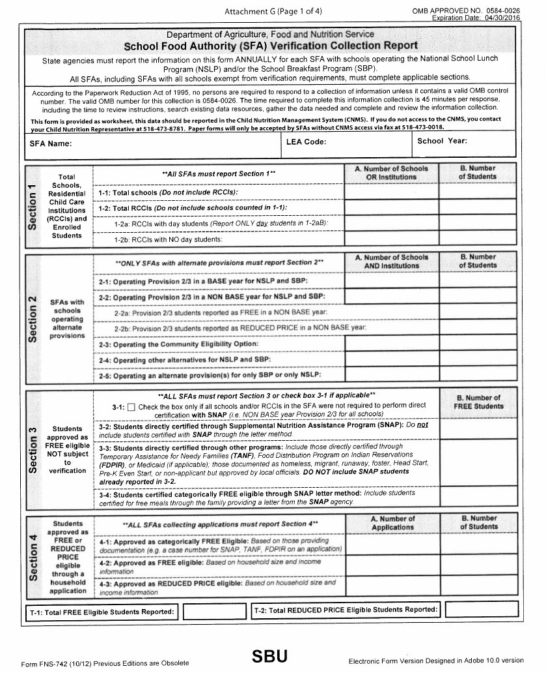
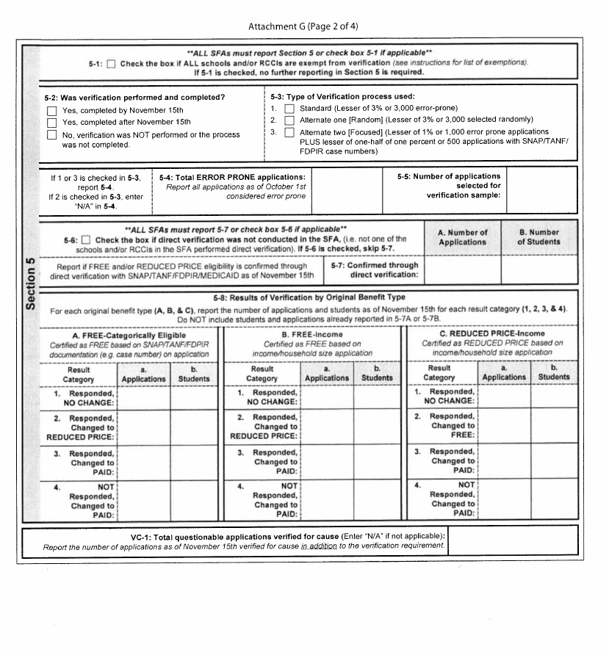
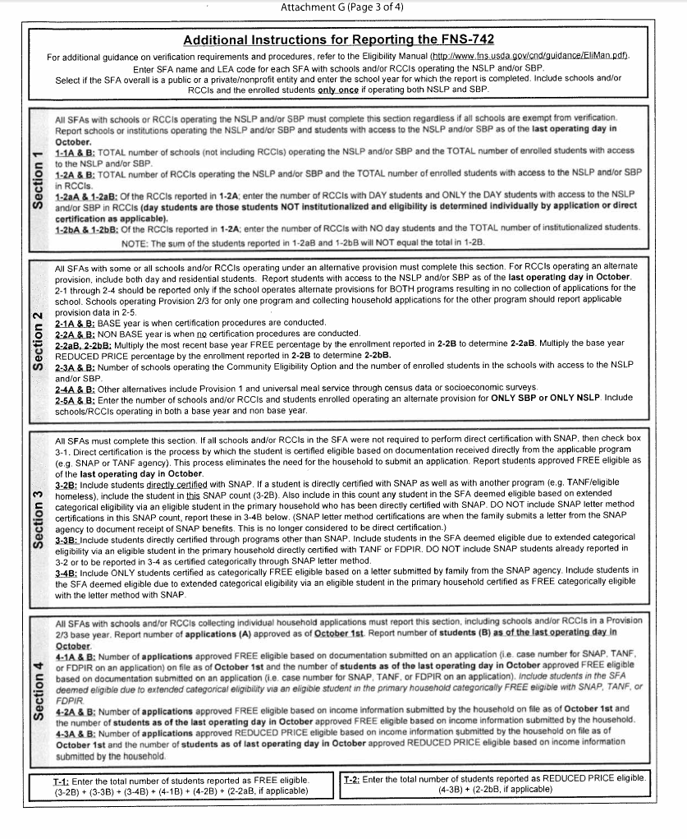

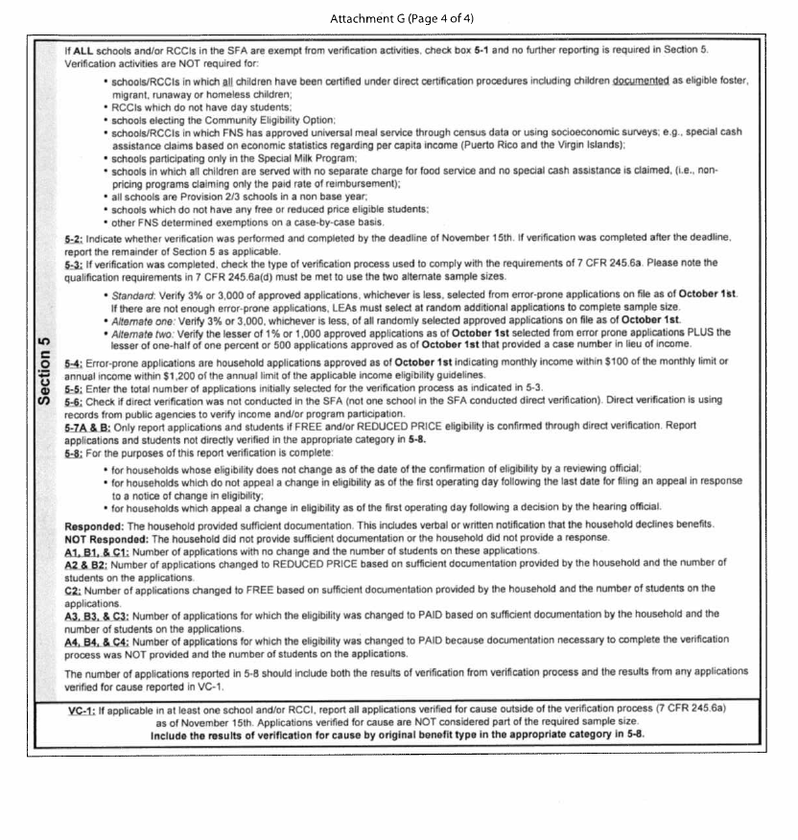

LEA CODE | SFA NAME
500402226478 | A H Schreiber Hebrew Acad Of Rocklan
331400225751 | Ach Tov V'Chesed
410401060000 | Adirondack CSD
142101040000 | Akron CSD
331500629812 | Al Madrasa Al Islamiya
450101060000 | Albion CSD
140101060000 | Alden CSD
220202040000 | Alexandria CSD
020101040000 | Alfred-Almond CSD
342700629235 | Al-Ihsan Academy
010100115684 | All Saints' Catholic Academy
421800185515 | All Saints Ele Of Tipperary Hill
031501187966 | All Saints School
460102040000 | Altmar-Parish-Williamstown CSD
310400860806 | Amber Charter School
662300625497 | Andalusia School
120102040000 | Andes CSD
500308990003 | Arc Rockland Co Chap
650101990003 | Arc Wayne County Chapter Inc
042400136448 | Archbishop Walsh High School
310100149000 | Archdiocese Of Ny
660405030000 | Ardsley UFSD
640101040000 | Argyle CSD
131601060000 | Arlington CSD
500401229697 | Ateres Bais Yaakov Acad Of Rockland
670201060000 | Attica CSD
222201155866 | Augustinian Academy-Elementary
090201040000 | Ausable Valley CSD
570201040000 | Avoca CSD
580101030000 | Babylon UFSD
080201040000 | Bainbridge-Guilford CSD
342800226480 | Bais Yaakov Academy For Girls
141800137227 | Baker Victory Services
420901060000 | Baldwinsville CSD
521301060000 | Ballston Spa CSD
401301040000 | Barker CSD
180300010000 | Batavia City SD
570302060000 | Bath CSD
580505020000 | Bayport-Blue Point UFSD
231301040000 | Beaver River CSD
660102060000 | Bedford CSD
020801040000 | Belfast CSD
280253070000 | Bellmore-Merrick Central HS District
LEA CODE | SFA NAME
061001040000 | Bemus Point CSD
010201040000 | Berne-Knox-Westerlo CSD
332000206898 | Beth Jacob High School
010306060000 | Bethlehem CSD
280521030000 | Bethpage UFSD
420101189405 | Bishop Ludden Junior-Senior High Sch
010100115665 | Blessed Sacrament School
421800185466 | Blessed Sacrament School
661905020000 | Blind Brook-Rye UFSD
500402225674 | Bnei Yakov Yosef Of Monsey
342700228636 | Bnos Bais Yaakov Of Far Rockaway
332100227245 | Bnos Israel Of East Flatbush
342800225513 | Bnos Malka Academy
630101040000 | Bolton CSD
570401040000 | Bradford CSD
510101040000 | Brasher Falls CSD
580909020000 | Bridgehampton UFSD
260101060000 | Brighton CSD
171102040000 | Broadalbin-Perth CSD
261801060000 | Brockport CSD
062301040000 | Brocton CSD
250109040000 | Brookfield CSD
580203020000 | Brookhaven-Comsewogue UFSD
161601040000 | Brushton-Moira CSD
661201060000 | Byram Hills CSD
240201040000 | Caledonia-Mumford CSD
641610040000 | Cambridge CSD
021102040000 | Canaseraga CSD
600301040000 | Candor CSD
142601136593 | Cardinal O'Hara High School
280411030000 | Carle Place UFSD
480102060000 | Carmel CSD
662300516461 | Carol & Frank Biondi Educ Center
421800185572 | Cathedral Academy At Pompei
310200145242 | Cathedral High School
050401040000 | Cato-Meridian CSD
250201060000 | Cazenovia CSD
010100997850 | Center For Disability Services
661004060000 | Chappaqua CSD
662300860862 | Charter Sch-Educ Excellence
160801040000 | Chateaugay CSD
060503040000 | Chautauqua Lake CSD
090601020000 | Chazy UFSD
LEA CODE | SFA NAME
030701060000 | Chenango Valley CSD
472202040000 | Cherry Valley-Springfield CSD
440201020000 | Chester UFSD
280208997798 | Children'S Lrning Ctr-Ucp Nassau Ct
251601060000 | Chittenango CSD
140203806578 | Christian Central Academy
261501060000 | Churchville-Chili CSD
140801060000 | Clarence CSD
510401040000 | Clifton-Fine CSD
099000000000 | Clinton-Essex-Warren-Washing Boces
060701040000 | Clymer CSD
541102060000 | Cobleskill-Richmondville CSD
010500010000 | Cohoes City SD
500402226086 | Cong Yeshiva Of Greater Monsey Inc
500402226093 | Congregation Yeshivas Meon Hatorah
471701040000 | Cooperstown CSD
230201040000 | Copenhagen CSD
580105030000 | Copiague UFSD
571000808888 | Corning Christian Academy
310300149994 | Cristo Rey High School
150203040000 | Crown Point CSD
241101040000 | Dalton-Nunda CSD (Keshequa)
241001060000 | Dansville CSD
580107030000 | Deer Park UFSD
129000000000 | Delaw-Chenango-Madison-Otsego Boces
140707030000 | Depew UFSD
031301040000 | Deposit CSD
250301040000 | Deruyter CSD
400400136417 | Desales Catholic Elementary School
211003040000 | Dolgeville CSD
120301040000 | Downsville CSD
530101040000 | Duanesburg CSD
060800010000 | Dunkirk City SD
430501040000 | East Bloomfield CSD
490301060000 | East Greenbush CSD
580301020000 | East Hampton UFSD
310400999536 | East Harlem School At Exodus House
260801060000 | East Irondequoit CSD
580234020000 | East Moriches UFSD
580917020000 | East Quogue UFSD
280402030000 | East Williston UFSD
589100000000 | Eastern Suffolk Boces
580912060000 | Eastport-South Manor CSD
LEA CODE | SFA NAME
141201060000 | Eden CSD
520601080000 | Edinburg Common SD
470501040000 | Edmeston CSD
180901040000 | Elba CSD
590801040000 | Eldred CSD
150301040000 | Elizabethtown-Lewis CSD
622002060000 | Ellenville CSD
040901040000 | Ellicottville CSD
421800997437 | Elmcrest Childrens Center
070902060000 | Elmira Heights CSD
660409020000 | Elmsford UFSD
142601997712 | Erie County Nys A R C
420601040000 | Fabius-Pompey CSD
421001060000 | Fayetteville-Manlius CSD
022001040000 | Fillmore CSD
070600861078 | Finn Academy-An Elmira Charter Schoo
331800437980 | Flatbush SDa School
270601040000 | Fonda-Fultonville CSD
061503040000 | Forestville CSD
120701040000 | Franklin CSD
062201060000 | Fredonia CSD
010100997616 | Free School
060301040000 | Frewsburg CSD
021601040000 | Friendship CSD
520701040000 | Galway CSD
650902040000 | Gananda CSD
280218030000 | Garden City UFSD
260401060000 | Gates-Chili CSD
261600860826 | Genesee Comm Charter School
249000000000 | Genesee Valley Boces
240401040000 | Geneseo CSD
430700010000 | Geneva City SD
470202040000 | Gilbertsville-Mount Upton CSD
630300010000 | Glens Falls City SD
310500861012 | Global Community Charter School
141800860044 | Global Concepts Charter School
430901060000 | Gorham-Middlesex CSD (Marcus Whitman
511101060000 | Gouverneur CSD
042801060000 | Gowanda CSD
660410100007 | Graham Home For Children
640701040000 | Granville CSD
260501808815 | Greece Christian School
LEA CODE | SFA NAME
320800716855 | Greek American Inst Of NY
080601040000 | Greene CSD
581010020000 | Greenport UFSD
190701040000 | Greenville CSD
640801040000 | Greenwich CSD
442111020000 | Greenwood Lake UFSD
010802060000 | Guilderland CSD
061700308038 | Gustavus Adolphus Child & Family
630801040000 | Hadley-Luzerne CSD
250701040000 | Hamilton CSD
511201040000 | Hammond CSD
572901040000 | Hammondsport CSD
580905020000 | Hampton Bays UFSD
120906040000 | Hancock CSD
460701040000 | Hannibal CSD
310400860812 | Harbor Sci & Arts Charter School
310300515340 | Harlem Academy
310300861034 | Harlem Hebrew Language Academy
030501040000 | Harpursville CSD
660501060000 | Harrison CSD
641001040000 | Hartford CSD
580506030000 | Hauppauge UFSD
500201060000 | Haverstraw-Stony Point CSD (North Ro
591401226474 | Hebrew Day School Of Sullivan & Ulst
332200860955 | Hebrew Language Academy Charter
660203060000 | Hendrick Hudson CSD
511301040000 | Hermon-Dekalb CSD
512404040000 | Heuvelton CSD
620803040000 | Highland CSD
261600997698 | Hillside Childrens Center School
261101060000 | Hilton CSD
041401040000 | Hinsdale CSD
141701040000 | Holland CSD
081200185526 | Holy Family School
512001185654 | Holy Name Of Jesus Academy
431401040000 | Honeoye CSD
260901060000 | Honeoye Falls-Lima CSD
491401040000 | Hoosic Valley CSD
490501060000 | Hoosick Falls CSD
260401999477 | Hope Hall School
571800010000 | Hornell City SD
641301060000 | Hudson Falls CSD
190901040000 | Hunter-Tannersville CSD
LEA CODE | SFA NAME
022601136563 | Immaculate Conception School
220301060000 | Indian River CSD
580502020000 | Islip UFSD
610600010000 | Ithaca City SD
420411060000 | Jamesville-Dewitt CSD
572702040000 | Jasper-Troupsburg CSD
630601040000 | Johnsburg CSD
031502060000 | Johnson City CSD
420501060000 | Jordan-Elbridge CSD
662300990001 | Julia Dyckman Andrus Memorial Inc
660101030000 | Katonah-Lewisboro UFSD
150601040000 | Keene CSD
450607040000 | Kendall CSD
101401040000 | Kinderhook CSD
580805060000 | Kings Park CSD
620600010000 | Kingston City SD
310500860883 | Kipp Infinity Charter School
420807040000 | Lafayette CSD
630701040000 | Lake George CSD
151102040000 | Lake Placid CSD
200601040000 | Lake Pleasant CSD
662401060000 | Lakeland CSD
610801040000 | Lansing CSD
470801040000 | Laurens CSD
181001060000 | Le Roy CSD
280205030000 | Levittown UFSD
580104030000 | Lindenhurst UFSD
511602040000 | Lisbon CSD
210800050000 | Little Falls City SD
421501060000 | Liverpool CSD
240801060000 | Livonia CSD
280407229720 | Long Island Hebrew Academy
200701040000 | Long Lake CSD
230901040000 | Lowville Academy & CSD
280220030000 | Lynbrook UFSD
421504020000 | Lyncourt UFSD
251101040000 | Madison CSD
280212030000 | Malverne UFSD
660701030000 | Mamaroneck UFSD
431101040000 | Manchester-Shortsville CSD (Red Jack
280406030000 | Manhasset UFSD
110901040000 | Marathon CSD
421101060000 | Marcellus CSD
LEA CODE | SFA NAME
121401040000 | Margaretville CSD
621001060000 | Marlboro CSD
280216997856 | Martin De Porres School
140701139960 | Mary Queen Of Angels School
580206175613 | Maryhaven Center Of Hope
332200229244 | Masores Bais Yaakov Elementary
512001060000 | Massena CSD
170801040000 | Mayfield CSD
332100225701 | Mazel Day School
460901060000 | Mexico CSD
342400861048 | Middle Village Prep Charter School
541001040000 | Middleburgh CSD
471101040000 | Milford CSD
280503315797 | Mill Neck Manor School For The Deaf
580208020000 | Miller Place UFSD
150801040000 | Minerva CSD
441101040000 | Minisink Valley CSD
269100000000 | Monroe 1 Boces
441201060000 | Monroe-Woodbury CSD
591401060000 | Monticello CSD
471201040000 | Morris CSD
512101040000 | Morristown CSD
250401040000 | Morrisville-Eaton CSD
421800185583 | Most Holy Rosary School
140600136375 | Mt Mercy Academy
580207020000 | Mt Sinai UFSD
431201040000 | Naples CSD
261600165998 | Nativity Preparatory Academy
140801136238 | Nativity-Bvm School
261600166206 | Nazareth Elementary School
331900808781 | New Grace Education Center
101601040000 | New Lebanon CSD
320700996063 | New Life School (The)
650101060000 | Newark CSD
151001040000 | Newcomb CSD
400601060000 | Newfane CSD
610901040000 | Newfield CSD
400701060000 | Niagara-Wheatfield CSD
530301060000 | Niskayuna CSD
280204020000 | North Bellmore UFSD
280229020000 | North Merrick UFSD
651501060000 | North Rose-Wolcott CSD
661301040000 | North Salem CSD
LEA CODE | SFA NAME
280501060000 | North Shore CSD
580404030000 | Northport-East Northport UFSD
170901040000 | Northville CSD
081200050000 | Norwich City SD
412300185517 | Notre Dame Elementary School
412300189443 | Notre Dame Junior-Senior High School
500304030000 | Nyack UFSD
310200861104 | Nyc Charter School Of The Arts
280211030000 | Oceanside UFSD
550101040000 | Odessa-Montour CSD
342700100023 | On Our Way Learning Center
251400010000 | Oneida City SD
621201060000 | Onteora CSD
142301060000 | Orchard Park CSD
471601040000 | Otego-Unadilla CSD
141901137240 | Our Lady-Blessed Sacrament
600601060000 | Owego-Apalachin CSD
081501040000 | Oxford Academy & CSD
280506060000 | Oyster Bay-East Norwich CSD
061601040000 | Panama CSD
512501040000 | Parishville-Hopkinton CSD
500308030000 | Pearl River UFSD
181302040000 | Pembroke CSD
261201060000 | Penfield CSD
060601040000 | Pine Valley CSD (South Dayton)
660809030000 | Pleasantville UFSD
051101040000 | Port Byron CSD
580206020000 | Port Jefferson UFSD
280404030000 | Port Washington UFSD
512902060000 | Potsdam CSD
641401040000 | Putnam CSD
480503040000 | Putnam Valley CSD
489000000000 | Putnam-Northern Westchester Boces
142801137104 | Queen Of Heaven School
010402060000 | Ravena-Coeymans-Selkirk CSD
343000860822 | Renaissance Charter School
131801040000 | Rhinebeck CSD
062401040000 | Ripley CSD
580602860032 | Riverhead Charter School
261600997046 | Rochester School For The Deaf
280221030000 | Rockville Centre UFSD
580209020000 | Rocky Point UFSD
411800010000 | Rome City SD
LEA CODE | SFA NAME
560603040000 | Romulus CSD
620901060000 | Rondout Valley CSD
530515060000 | Rotterdam-Mohonasen CSD
121502040000 | Roxbury CSD
401201060000 | Royalton-Hartland CSD
661901030000 | Rye Neck UFSD
580205060000 | Sachem CSD
221001040000 | Sackets Harbor CSD
641501040000 | Salem CSD
161201040000 | Salmon River CSD
091402060000 | Saranac CSD
521800010000 | Saratoga Springs City SD
530501060000 | Schalmont CSD
491501040000 | Schodack CSD
541201040000 | Schoharie CSD
560701060000 | Seneca Falls CSD
091200155496 | Seton Academy
091101159175 | Seton Catholic Central High School
030200185471 | Seton Catholic Central Jr/Sr High
332100228724 | Shaare Torah School
541401040000 | Sharon Springs CSD
580701020000 | Shelter Island UFSD
520302060000 | Shenendehowa CSD
062601040000 | Sherman CSD
332100226933 | Shulamith School For Girls-Brooklyn
061501040000 | Silver Creek CSD
651201060000 | Sodus CSD
662101060000 | Somers CSD
010601060000 | South Colonie CSD
521401040000 | South Glens Falls CSD
220101040000 | South Jefferson CSD
121702040000 | South Kortright CSD
500301060000 | South Orangetown CSD
580906030000 | Southampton UFSD
141604136382 | Southtowns Catholic School
060201060000 | Southwestern CSD At Jamestown
131602020000 | Spackenkill UFSD
600801040000 | Spencer-Van Etten CSD
471101997806 | Springbrook New York, Inc
141101060000 | Springville-Griffith Inst CSD
141101136383 | St Aloysius Regional School
142601136293 | St Amelia School
010100115658 | St Anne Institute
LEA CODE | SFA NAME
010623995677 | St Colman's School
141604136402 | St Francis High School
140203136273 | St Gregory The Great School
031502185486 | St James School
511101155007 | St James School
400701325766 | St John Lutheran School
260801165157 | St John Neumann School
140101136379 | St John The Baptist School
142601136418 | St John The Baptist School
142301136271 | St John Vianney School
140600136295 | St Joseph University School
140600136376 | St Mark School
490501117509 | St Mary'S Academy-Elementary
141901136283 | St Mary'S Elementary School
151501155883 | St Mary's School
140203136252 | St Mary's School
140203136333 | St Peter & Paul School
400301136456 | St Peter School
260401166221 | St Pius X School
161801040000 | St Regis Falls CSD
401001060000 | Starpoint CSD
400301136253 | Stella Niagara Educ Park
522001040000 | Stillwater CSD
251501040000 | Stockbridge Valley CSD
591502040000 | Sullivan West CSD
100501040000 | Taconic Hills CSD
140600860838 | Tapestry Charter School
220701040000 | Thousand Islands CSD
580201060000 | Three Village CSD
600903040000 | Tioga CSD
142500010000 | Tonawanda City SD
280300206622 | Torah High School Long Beach
211901020000 | Town Of Webb UFSD
512001155896 | Trinity Catholic School
611001040000 | Trumansburg CSD
580913080000 | Tuckahoe Comn SD
660302030000 | Tuckahoe UFSD
421902040000 | Tully CSD
441903020000 | Tuxedo UFSD
051901040000 | Union Springs CSD
031501060000 | Union-Endicott CSD
140600999851 | Universal School
490804998235 | Vanderheyden Hall
LEA CODE | SFA NAME
431701060000 | Victor CSD
260501996191 | Villa Of Hope
353100880287 | Vol Of America-Greater Ny Inc
321100806052 | Wake-Eden Christian Academy
621801060000 | Wallkill CSD
442101060000 | Warwick Valley CSD
522101030000 | Waterford-Halfmoon UFSD
011200010000 | Watervliet City SD
650801060000 | Wayne CSD
050301040000 | Weedsport CSD
022601060000 | Wellsville CSD
210302040000 | West Canada Valley CSD
260803060000 | West Irondequoit CSD
580509030000 | West Islip UFSD
440301998250 | West Point Elementary School
040204040000 | West Valley CSD
589300000000 | Western Suffolk Boces
062901040000 | Westfield CSD
580902020000 | Westhampton Beach UFSD
420701060000 | Westhill CSD
151601040000 | Westport CSD
262001040000 | Wheatland-Chili CSD
170301020000 | Wheelerville UFSD
641701060000 | Whitehall CSD
022101040000 | Whitesville CSD
031401060000 | Whitney Point CSD
651402040000 | Williamson CSD
151701040000 | Willsboro CSD
191401040000 | Windham-Ashland-Jewett CSD
031701060000 | Windsor CSD
472506040000 | Worcester CSD
490804020000 | Wynantskill UFSD
500402229165 | Yeshiva Degel Hatorah
500402229549 | Yeshiva Gedolah Of South Monsey
500402228999 | Yeshiva High School Of Monsey
342500229646 | Yeshiva Ketana Of Queens
332100226947 | Yeshiva Of Brooklyn
342500227011 | Yeshiva Of Central Queens
500402226477 | Yeshiva Of Spring Valley
310600226845 | Yeshiva Rabbi S R Hirsch
342900226050 | Yeshiva Rlkti Primary
342800229850 | Yeshiva Sha'Arei Zion Ohel Bracha
590501226115 | Yeshiva Zichron Mayir
LEA CODE | SFA NAME
332200226034 | Yeshivat Ohel Torah
662300809020 | Yonkers Christian Academy
241701040000 | York CSD
043501060000 | Yorkshire-Pioneer CSD
662402060000 | Yorktown CSD

CHILD NUTRITION PROGRAM ADMINISTRATION
89 Washington Avenue, Room 375-EBA, Albany, NY 12234

NEW YORK STATE EDUCATION DEPARTMENT

(518) 473-8781 Fax (518) 473-0018

www.cn.nysed.gov

Paula Tyner Doyle, Director

Sandra Sheedy, FPES III

Kimberly Vumbaco, FPES III

Altameice Robertson-Gray, Secretary I
Eileen Becker, Support Staff | Jacquelyn Bolon, Support Staff
 | Kacilyn Ritrovato, Support Staff
Team 1  Raemie Swain, FPES II  Kristin Junco, Erin Putnam, Caitlyn Parry, Jesse Sajdak, Linda Snyder, Elaine Reynolds, Daniel Sohotra, Jennifer Glasser  Counties: Chautauqua, Chemung, Clinton, Cortland, Essex, Fulton, Madison, Manhattan, Oneida, Onondaga, Oswego, Putnam, Rockland, Schenectady, Tioga, Washington and Westchester | Team 2  Jenni Knapp, FPES II  Meghan Usher, Shannon Rocco, Laura Matturro, Amanda Lanahan, Linda St. Pierre, Susan Adinolfe  Counties: Broome, Cattaraugus, Chenango, Columbia, Delaware, Genesee, Herkimer, Orleans, Queens, Rensselaer, Schuyler, Seneca, St. Lawrence, Suffolk, Wayne and Wyoming
Team 3  Jamie McMillian, FPES II  Todd Bradshaw, Eric Maryzak, Karen Ulrich  Katie Kovage, MaryBeth Sotir, Kathryn Oliver, Nicole Clark  Counties: Allegany, Bronx. Cayuga, Dutchess, Erie, Franklin, Greene, Hamilton, Livingston, Montgomery NYCDOE, Otsego, Richmond, Saratoga, Tompkins, Warren and Yates | Team 4  Tara Webster, FPES II  Ashlene Regis-Koudoagbo, Colleen Wise, Kristin Ricciardi, Stacy Stenglein, Emily Handy, Kendra Roche, Elizabeth Hanus  Counties: Albany, Jefferson, Kings, Lewis, Monroe, Nassau, Niagara, Ontario, Orange, Schoharie, Steuben, Sullivan and Ulster
SUMMER FOOD SERVICE PROGRAM  (518) 486-1086 Fax (518) 474-9920  Monica Lasher, FPES II  Meghan Taney, Michelle Crawford, Cady Warenda, Marisa Hutson, Eliza O’Donnell, Liza Multari, Steve Hanson  Serving all counties  (518) 486-1086 Keith Quenneville - Support Staff | TRAINING TEAM  Michele Beaver, FPES II  Sarah Leavitt | Kylie Smith, FPES II
AUDIT TEAM

Jeanne Day, Associate Auditor
Wadler St. Jean, Senior Auditor
Amanda Watson, Senior Auditor

