2021-2022 Annual Renewal Online Instructions/SSO Election
All School Food Authorities (SFA) participating in the National School Lunch Program, School Breakfast Program and/or Special Milk Program are required to complete an Annual Renewal prior to the beginning of the school year. SFAs electing to operate the Seamless Summer Option (SSO) of the National School Lunch Program using the USDA waiver flexibilities for the 2021-2022 school year, must complete this renewal and indicate the SSO election for each Recipient Agency (RA)/site, as applicable.
The purpose of the Annual Renewal is to recommence the SFAs’ single permanent agreement between New York State Education Department (SED) and the SFA. Please refer to the following for more information: Single Permanent Agreement. The Annual Renewal is also the mechanism for SED to collect annual program specific information. SFA’s are required to notify SED of any changes that occur throughout the school year.
Failure to complete the annual renewal prior to the start of the school year may jeopardize reimbursement and may result in the SFA’s program participation being deemed abandoned. No Renewals will be accepted after December 1st, 2021. In the event that the SFA fails to renew, the SFA will be required to submit a new SFA program application in accordance with Child Nutrition Program Administration (CNPA) procedures during the designated annual enrollment period. In addition, the SFA will be subject to a close out review in accordance with CNPA procedures.

The following directions must be followed in order to update information
To access the renewal, log into the Child Nutrition Management System (CNMS) with your username and password, go to the blue menu bar under “Program", select “SFA Profile/Renewal” from the drop-down menu, select the year 2021-2022 and click “Find”. The 2021-2022 school year profile/renewal will display.

DUNS Number and SAM Expiration Date
- In order to be awarded federal funds an agency must obtain a DUNS number that is registered with the federal System for Award Management (SAM). Your SFA will not be able to complete the annual renewal for your Child Nutrition Programs until a DUNS number has been obtained and registered through the SAM system. This requirement is in accordance with the Federal Funding Accountability and Transparency Act (FFATA) of 2006, Public Law 109-282.
- Once you have clicked into the SFA Profile Renewal for the 2021-2022 school year, check to see if there is a DUNS number and current expiration date.
- If the DUNS number has expired, click on “Click here to renew SAMS”.​
  - After the renewal of the DUNS number, it will take one week to renew. Please keep this in mind to be in compliance with the Annual Renewal deadline.
- For more information on the DUNS number, expiration date and instructions on how to register with the federal SAM system, please refer to the following site: http://www.oms.nysed.gov/cafe/guidance/sam.html.

Contact Information
Review all contact information to ensure that this information is accurate and complete. Please note, that after each update it is necessary to click “Program” on the tool bar, select “SFA Profile/Renewal” and the “2021-2022” school year in order to return to the renewal. Do NOT use the back button on your web page browser.
- Verify your SFA’s name and address. Address information is provided by The State Education Department Reference File (SEDREF).
  - Residential childcare institutions or jails should contact your Child Nutrition Representative at (518) 473-8781 for assistance regarding name and/or address changes.
  - If you are a representative from a School District, Public School, Nonpublic School, Charter School or BOCES and you need to contact SED for a change in your contact information (including Director of Special Ed), or for a BOCES virtual location, please proceed as follows:
    - For Nonpublic School CFO information, the change must be captured on this CFO form or this CFO form in PDF and emailed to datasupport@nysed.gov
    - For all other contact info changes, including CEO, for the above types of Institutions, the change must be on the Institution's letterhead and emailed to datasupport@nysed.gov
**Do not send letters to the Child Nutrition office requesting name and/or address changes since our office cannot process these changes. Name and/or address changes for public or nonpublic schools must be made by the Office of Information, Reporting and Technology Services as specified above.**
- Review the Food Service Director, Fiscal Contact and School Business Official contact information to ensure it is accurate and complete. Since we often contact SFAs by telephone, fax or e-mail, it is important that you maintain current information in your user profile.
  - If there are any changes for the Food Service Director, Fiscal Contact and School Business Official, click on the underlined title which corresponds with the information that is missing or needs updating. This will bring you back to the CNMS home page. To update a contact person’s information or to change the contact person, click on the corresponding contact name under Contact People.
    - Complete the following steps:
      - To change the name of the contact person, click on the first “New” button under Contact People.
      - Enter the contact person’s name and choose their role by using the drop-down box next to the words “Contact Role.” Then click insert. You will see the word “Success!” in green.
      - Next click on “Back to SFA.”
      - To change the phone number, e-mail and fax click on the second “New” button under Phone/Fax/Email.
      - Choose from “Device Type” and enter the information in the “Value” box then click on the “Insert” button. Again, you will see the word “Success!” in green.
      - Once this is completed go to program at the top of the screen and then click on “SFA Profile/Renewal” and choose the 2021-2022 school year to get back to the Annual Renewal Home Page.
  - The name and telephone number of the Food Service Director, Fiscal Contact and School Business Official are required fields. Failure to enter required fields will result in not being able to submit your online renewal. The Fiscal Contact is the person who should be contacted if there are questions about claims submitted by the SFA.

Certification of Acceptance

*Please note, this information is not required if all the RA’s within the SFA participate in Provision 2 or Community Eligibility Provision or if ALL RAs/Sites within the SFA are electing SSO during 2021-2022SY.
- The Free and Reduced Price Meal Policy Certification of Acceptance, found in the 2021-2022 Free and Reduce Price Income Eligibility and Policy Information Booklet, is available online at www.cn.nysed.gov. The Certification of Acceptance must be completed as part of the annual renewal process designating a Reviewing Official, Verification Official and a Hearing Official. The Hearing Official must be someone removed from the application review and approval process.
- The name and titles of the Reviewing Official, Verification Official, and Hearing Official are required fields.
  - To begin entering the name and titles of the designated officials, click on the underlined title “Reviewing Official”, then click on the “New” button under the heading “Certification Officials”. Enter the Name, Title, and select the type of official; then click “Insert”. Repeat this process to enter the Verification Official and the Hearing Official. After all, three official’s information have been entered, go to the blue menu bar at the top of the page and click on “Program”, then “SFA Profile/Renewal” and choose the 2021-2022 school year to return to the Annual Renewal Home Page.
  - ​The Reviewing Official and Verification Official may be the same person; however, the Hearing Official cannot be the Reviewing or Verification Official. A Message will appear if the same name is entered for the Hearing Official and either the Reviewing or Verification Official.

Exemptions/Waivers
- If your SFA has previously been approved for the RCCI Age/Grade Group and/or one of the Religious Exemption Waivers, the specific exemption/waiver that is approved will be noted on the Annual Renewal. SFAs may apply for these available exemptions/waivers by completing the process detailed in the applicable memos that are posted on the Child Nutrition Knowledge Center (CNKC). This is not done online through the annual renewal process and differs from the COVID-19 related waivers that are explained below. For more information on these available exemption/waivers, please contact your Child Nutrition Program Representative.

- COVID-19 related USDA waiver flexibilities: SED has elected the use of the Nationwide waiver flexibilities provided by the United States Department of Agriculture (USDA) for school year 2021-2022. These waivers are intended to facilitate streamlined access to nutritious meals and snacks, while minimizing potential exposure to COVID-19.
During the annual renewal process, SFAs should review and elect waivers, as applicable. To view and elect waivers, click the “SFA Waiver” link on the annual renewal screen. Waivers are also accessible by going to your SFA Annual Information, clicking the 2021-2022 School Year and scrolling down to the waiver section.
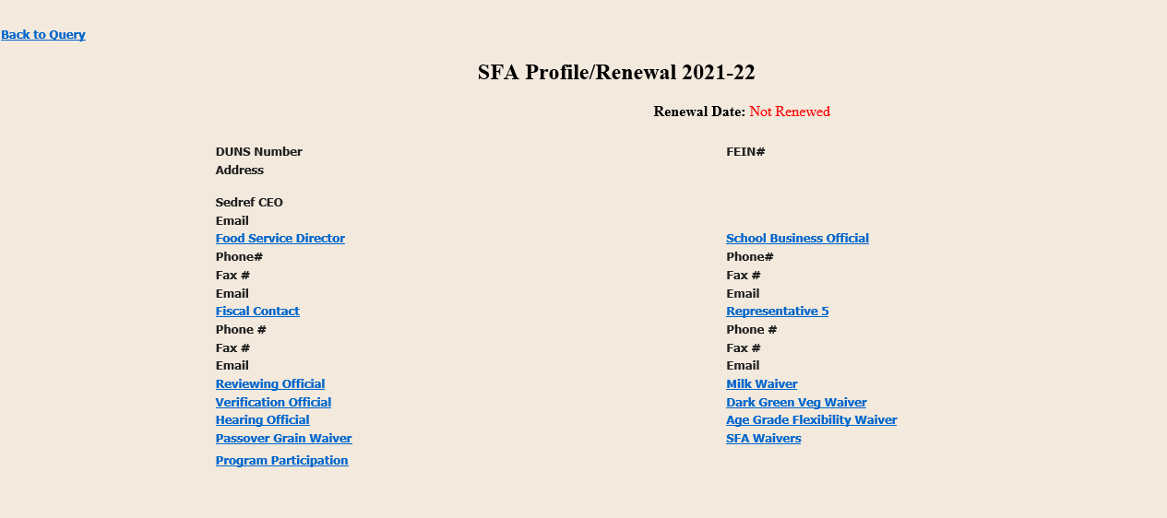
Please note, electing to operate the Seamless Summer Option (SSO) of the National School Lunch Program is explained further in these instructions. This waiver section refers to USDA Waiver Flexibilities found here.
1. Review your SFAs previously approved USDA waivers:
If your SFA elected waivers and operated in SSO, National School Lunch or School Breakfast Program during the 2020-2021 School Year (SY), the waiver election(s) will carry over in CNMS to SY 2021-2022. SFAs must review the waivers currently elected in CNMS for the 2021-2022 SY and update the waiver election & related information, as applicable. Waivers did not carry over for SFAs that elected waivers and operated under the Summer Food Service Program for 2020-2021.
  - If your SFA no longer wishes to use a waiver that carried over from last school year, you must make the specific waiver “inactive” for the 2021-2022 SY. Do this by clicking on the name of the waiver, choosing the drop down next to Active, and selecting “N.”

  - If your SFA will continue to use a waiver in the 2021-2022 SY that was carried over from last year, you should review the information entered for the waiver and make changes as necessary.

    - Any change to program operations should be noted in the “details” section of the waiver. If operations are consistent with last school year, no additional comments are required.
2. Elect new waivers, as applicable:
If there is a new waiver you would like to elect for the 2021-2022 SY, you may add it by following the steps below:
  - Under the waiver section, click “new” to add a waiver not already noted on the SFA Annual Information Page
  - Select the waiver from the drop-down box and include details and comments, as applicable
  - If the waiver applies to all RAs, select “Y” in the drop-down box titled “Apply to all Recipient Agencies” or enter the RA names the waiver will apply to.
  - Continue to select applicable waivers from the drop-down box until all desired waivers are included. Please note: if electing to offer bulk meals, you must also apply for Non-Congregate AND Meal Service Time waivers
Detailed instructions for electing waivers that include screenshots can also be found here.
Your Child Nutrition Program Representative will review the information entered for the waivers and contact you if additional detail is necessary.

Approved Programs
- Approved programs are displayed next to “Program Participation” on the SFA Profile/Renewal page. Lunch participation is designated as “Under 60%” or “Over 60%” in reference to the percentage of free and reduced lunches served in the 2019-2020 school year, excluding emergency meals. Over 60% SFAs receive an additional $.02 for each lunch served.
- If your SFA no longer participates in a program that is listed for the 2021-2022 school year, immediately notify your Child Nutrition Representative in writing. This cannot be changed online.

Recipient Agency (RA) Information

All RAs that have been approved to operate for the 2021-2022 school year under your SFA will be listed on the renewal. For each RA, review and update the information as follows in the instructions below.

If your SFA would like to serve meals at a new RA (school) and/or at a meal service site (SSO operations only) that is not currently approved and listed on the renewal, you will need to notify your Child Nutrition Program representative and follow the appropriate application process:
  - New Recipient Agency (RA): SFAs may apply to operate the Child Nutrition Programs at a new RA (school) according to the established application process found here: Child Nutrition Programs Application Submission Process | Child Nutrition | NYSED

  - SSO non-school meal service location: If your SFA will be serving meals at a location that is not a school, contact your Child Nutrition Program Representative to request a New Site Information Sheet (NSIS). Please note, the NSIS will be reviewed by the Child Nutrition Program office to determine if the site is allowed to operate. You must receive approval to operate at the location prior to beginning program operations.

RA Information to review and update:
- Review and verify the information noted for breakfast, lunch, snack and Special milk programs for each RA.
  - If a breakfast, lunch, Special milk or snack program for an individual RA needs to be removed, you must notify your Child Nutrition Program Representative in writing. Requests to delete programs for an RA cannot be done online.
  - New RA programs cannot be added online. If you wish to add a program to your existing RA, submit a request for a Program Addition Form which can be found at the following link http://www.cn.nysed.gov/form/new-application-request-form
- Verify the names and addresses for each RA. RA name and address information is provided by The State Education Department Reference File (SEDREF).
  - If you are a representative from a School District, Public School, Nonpublic School, Charter School or BOCES and you need to contact SED for a change in your contact information (including Director of Special Ed), or for a BOCES virtual location, please proceed as follows:
    - For Nonpublic School CFO information, the change must be captured on this CFO form or this CFO form in PDF and emailed to datasupport@nysed.gov
    - For all other contact info changes, including CEO, for the above types of Institutions, the change must be on the Institution's letterhead and emailed to datasupport@nysed.gov
  - Do not submit claims for cancelled RAs or combine the claim with another RA without submitting the paperwork and obtaining approval for a new RA.

For each Recipient Agency repeat the following steps
- Indicate the Method of Service for each building by clicking on “Method of Service."
The different methods of service are as follows:
- Satellite – Meals are not prepared at the site
- Sat-Prep – Meals are prepared and served on site and sent to additional sites
- Self-Prep – Meals are prepared on site and served only at this site
- Vended – Prepared meals are delivered from an outside organization
  - If vended, enter the vendor’s name in vendor field​
- After you have entered the Method of Service, click the “Update” button then scroll to the top of the screen and click on “SFA/Profile Renewal” to return to the Annual Renewal Home Page. Repeat this process for each RA.
- ​Grade Levels: ​​​Enter the participating grade levels for each building by clicking on “Grades in Building” and checking the appropriate boxes. Click the “Update” button.
- Seamless Summer Option (SSO):
  - If your SFA is electing to operate SSO at the RA, click the “SSO” link from the renewal screen. Next, check the SSO box under RA annual information and click the “update” button. The RA is now entered in CNMS as operating SSO for the operating months the RA is currently approved for.
*Please note that once SSO is elected, the site will automatically be made a “closed enrolled site” to serve the RAs enrolled student population.
SFAs operating under SSO for July and August are only permitted to serve enrolled students.
SED is waiting for additional guidance from USDA regarding operations beginning in September 2021. Specifically, we are waiting for clarification on:
- If open sites are allowed to operate from September 2021-June 2022
- If SFAs may include non-enrolled students (example- siblings) in their SSO closed-enrollment from September 2021-June 2022
Once this guidance is provided, the information will be posted to the Child Nutrition Knowledge Center.
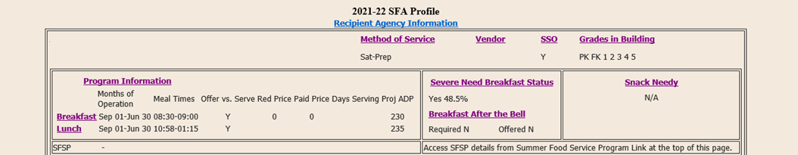

Breakfast After the Bell (BAB)
“Breakfast After the Bell” is when a SFA offers all students a school breakfast after the instructional day has begun. Schools can offer Breakfast After the Bell by implementing the alternative breakfast service model such as breakfast in the classroom, “grab and go” breakfast, and second chance breakfast.
- Scroll down to “Recipient Agency Programs” to complete Breakfast After the Bell (BAB) information
- Click on “Breakfast” under Program Name.
- Scroll down to “BAB required” to confirm if the RA is mandated to implement BAB.​
- Next click on the drop-down box to choose “Y” (yes) or “N” (no) for “BAB Offered”. If mandated to implement BAB, the SFA is required to indicate which BAB Method(s) are used or request a waiver. If the SFA is not mandated but offered BAB it is required to indicate which BAB method(s) are used.
  - If “Y”, indicate which “BAB Method” used. Click the “Update” button.
- For RAs required to offer BAB but would like to apply for a waiver the information can be found at: http://www.cn.nysed.gov/form/breakfast-after-bell-waiver-request
- Repeat this process for each RA.

Meal Service Times, Prices, Offer vs Serve & Average Daily Participation (ADP)
- To update Meal Service Times, Prices and Offer vs Serve information, click the “Recipient Agency Information” link that can be found in the middle of the screen above where your RAs are listed. This will allow you to enter the information by program for all RAs at one time. You may also update this information individually for each RA by clicking each program listed within the RA.​
- Meal Service Times are rolled over from last year. Please update the times if the program serving times have changed.
  - Meal Service Time Waiver for 20-21SY: Program regulations require that breakfast be served close to the beginning of the school day and lunch be served within the required meal hours of 10:00am-2:00pm. If your RA is serving breakfast and/or lunch outside of these required timeframes, your SFA should apply for the meal service time waiver that is available for the 2021-2022 School Year. See the waiver section of these instructions for how to apply.
- Prices: Enter the prices charged to the Paid Price students for the 2021-2022 school year.
  - Schools are required to charge students for paid meals at a price that is on average equal to the difference between free meal reimbursement and paid meal reimbursement; Schools that currently charge less are required to gradually increase their prices over time until they meet these requirements.
  - When charging multiple paid lunch prices, enter the most frequently used price.
  - SFAs that do not charge students should enter zero (“0”) into the price field, including RAs operating SSO.
- Offer vs. Serve: Ensure the option is correctly indicated “Yes” or “No” for each RA. If the option is incorrect, select the correct response and click “Update”.
- Proj ADP (Projected Average Daily Participation): The projected ADP will be displayed for each RA by program (breakfast, lunch and/or snack) and is based on claims from the 2019-2020 school year, excluding emergency meals. Review the projected ADP for each program and ensure it is an accurate projection for the 2021-2022 school year. Changes to the projected ADP cannot be made in CNMS by your SFA. If you need to make a change to the ADP listed on your renewal, please email your CN representative prior to beginning program operations.
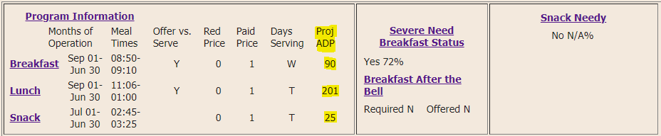
- After the updates have been made, click the “Update” button then go to the blue menu bar at the top of the page and click on “Program”, then “SFA Profile/Renewal” and choose the 2021-2022 school year to return to the Annual Renewal Home Page.

Days of Operation by Program - to be completed for ALL Non-public SFAs
- All SFAs must enter days of operation by program for each RA.
- To enter the days of operation, complete the following steps for each RA:​
  - Within each RA, under the “Program Information” click on the program you wish to enter the days of operation for (Breakfast, Lunch, Snack)
  - Under the heading “Days” click on “New”
  - Enter all days of operation for the program and then click insert.
  - Go to the blue menu bar at the top of the page and click on “Program”, then “SFA Profile/Renewal” and choose the 2021-2022 school year to return to the Annual Renewal Home Page.
  - Repeat the above steps for each program and RA

The information below is automatically generated by CNMS and will not require updating
- Menu Option - Food Based Menu Plan is pre-filled since no other menu plan is allowed.
- Severe Need Breakfast Status is indicated for 2021-2022 school year as: “No” (Regular) or “Yes” (Severe Need). The percentage of free and reduced price lunches served in the 2019-2020 school year excluding emergency meals, is also shown. If the percentage indicated is 40% or more, the RA qualifies for Severe Need reimbursement for the 2021-22 school year.
- “Snack Needy” Status is listed next to each RA if the RA participated in snack during the 2019-2020 school year. If 50% or more of the students in the RA are eligible for free and reduced meals, then the RA is “Snack Needy” eligible. Once a RA is determined to be "Snack Needy" eligibility will continue for five years.
  - SFAs that elect the COVID-19 waiver for Area Eligibility in the Afterschool Snack program, will be noted in CNMS as “Snack Needy” through the end of the 2021-2022 SY after the waiver has been elected and reviewed by CN.
- Months of Operation for the current year are listed. If the beginning start date of the SFA is changing from September to July or August, submit a letter on your school’s letterhead explaining the educational nature of the program being offered to this office. This cannot be changed online.

Submitting the Annual Renewal
- Once you have completed the review and update of your SFA’s renewal, read the certification statement and click “I Agree”. Your Annual Renewal is then processed. If you do not see this message, recheck all fields to ensure that a required field was not unintentionally left blank.
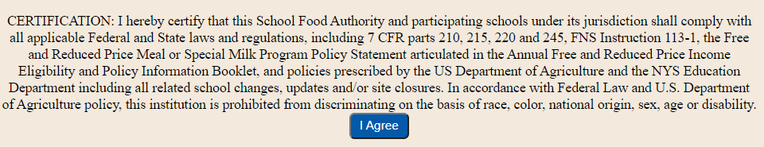
*It is important to note that information contained in the SFA and RA annual information screens, as well as the contact people module and RA general information screens, must be updated any time there is a change during the school year to ensure we have the most up-to-date information on file. Failure to do so may result in the withholding of payments, suspension or termination of the program.

