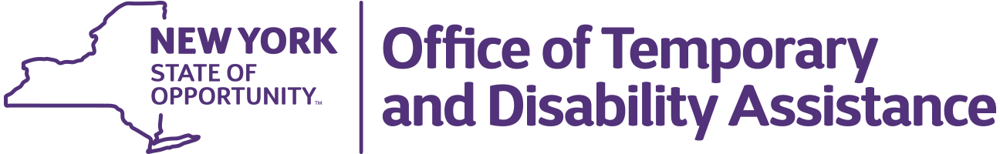
Kathy Hochul
Governor

BARBARA C. GUINN
Acting Commissioner

Information for Families about
P-EBT Benefits for 2021-22 School Year, Summer 2022, and Summer 2023

The New York State Office of Temporary and Disability Assistance (OTDA) is issuing Pandemic Electronic Benefit Transfer (P-EBT) food benefits for the 2021-22 school year and the summer 2022 and 2023 periods.

Application for Additional Benefits
If your eligible child was absent or remote learning for any number of days in a month due to COVID-19 in the 2021-22 year, you can apply to see if they are eligible for additional benefits. Visit the P-EBT Food Benefit Application at https://pebtbenefits.ny.gov, log in, and check the list of schools to see if your child’s school is listed. If it is, you can apply for additional benefits by reporting the number of days your child was absent or remote by month and confirm that it was due to COVID-19.

The deadline to apply is September 30th, 2023. More information about completing and submitting an application is available at https://otda.ny.gov/PEBT-FAQs

For More Information or Questions
OTDA provides updates on benefit issuances at https://otda.ny.gov/SNAP-COVID-19/. If you have questions, you may call the P-EBT food benefits Helpline: 1-833-452-0096 or fill out the P-EBT Information Form at https://otda.ny.gov/PEBT-Info to submit a question in writing. More information about P-EBT is available at https://otda.ny.gov/PEBT-FAQs

